**River Restoration Strategy – River Lyvennet at Barnskew and Meaburn Hall – Penrith Cumbria – Aerial photos August 2013**

1. **River Lyvennet and Howe Beck from Meaburn Hall looking downstream**

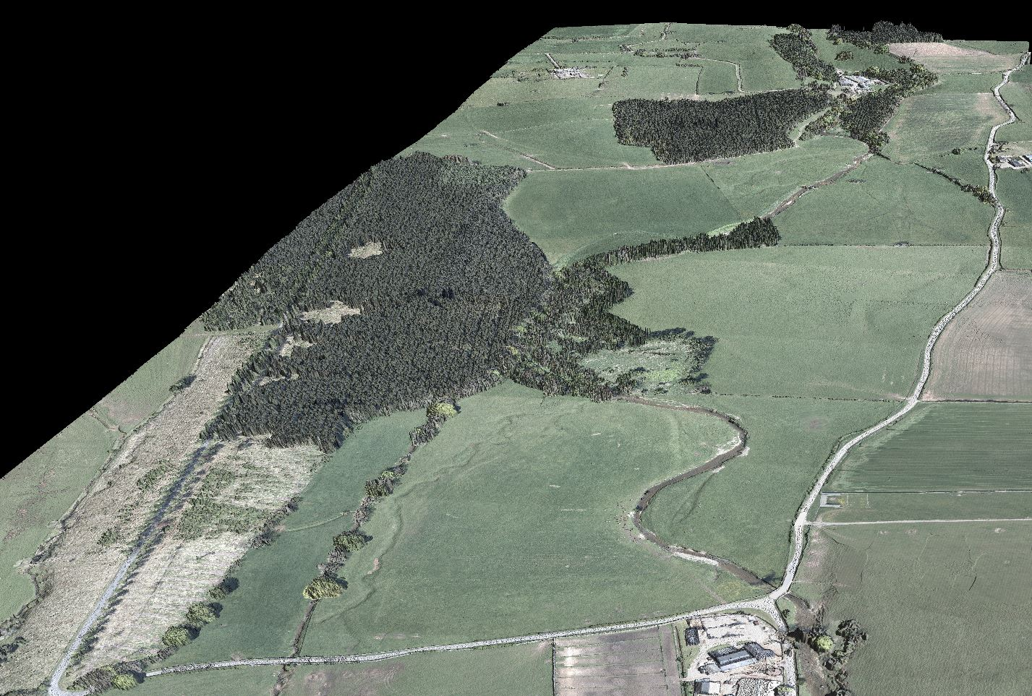

1. **River Lyvennet and Howe Beck from Meaburn Hall looking downstream**

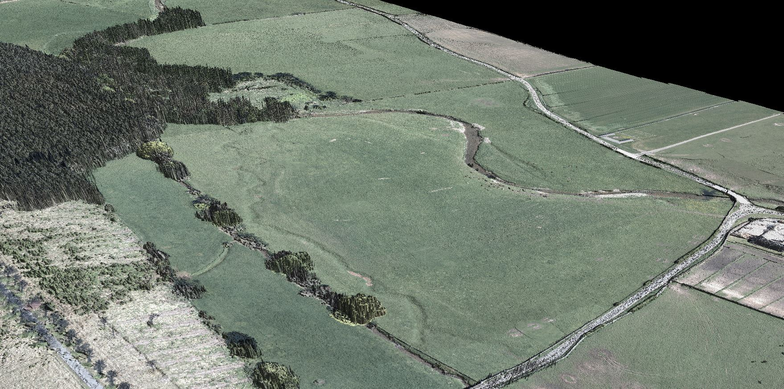

1. **River Lyvennet and Howe Beck from Barnskew looking upstream**

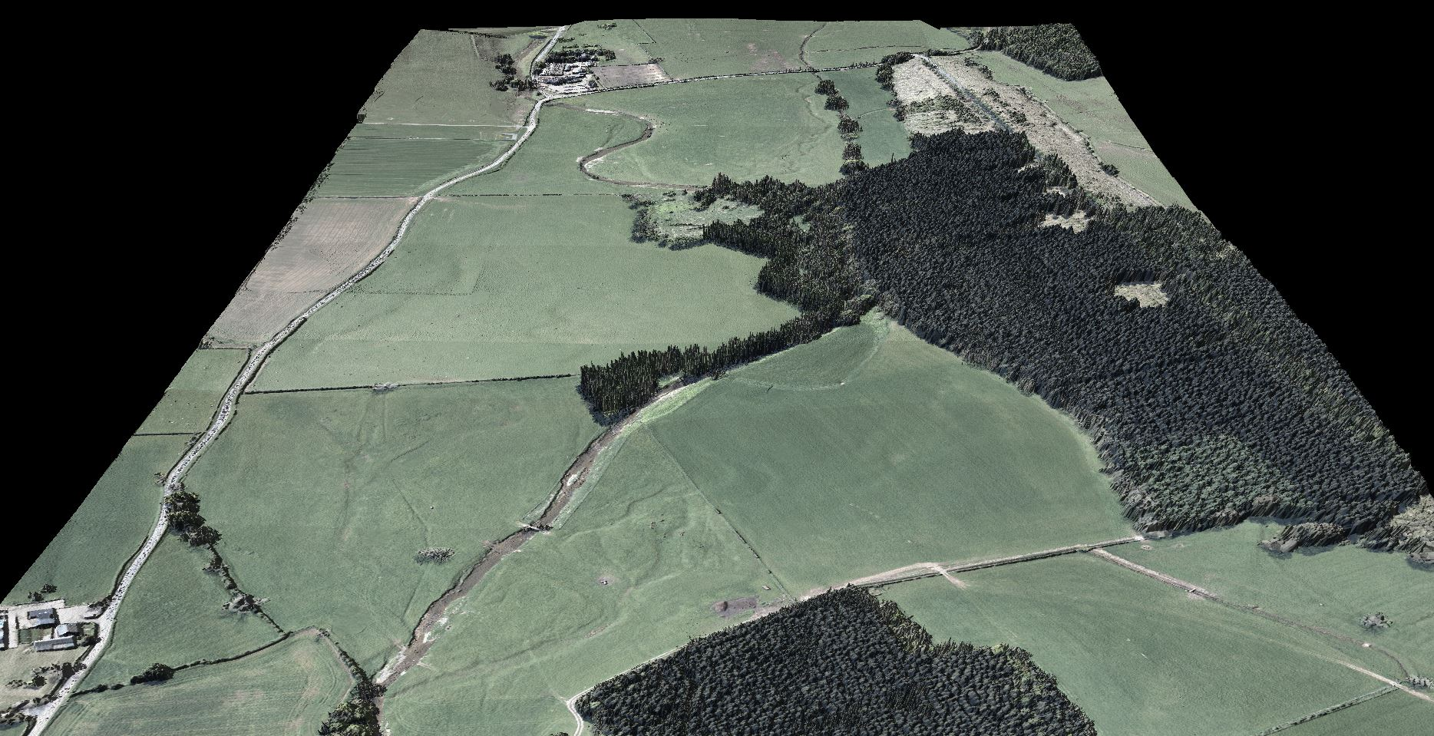

1. **River Lyvennet from Barnskew looking upstream**

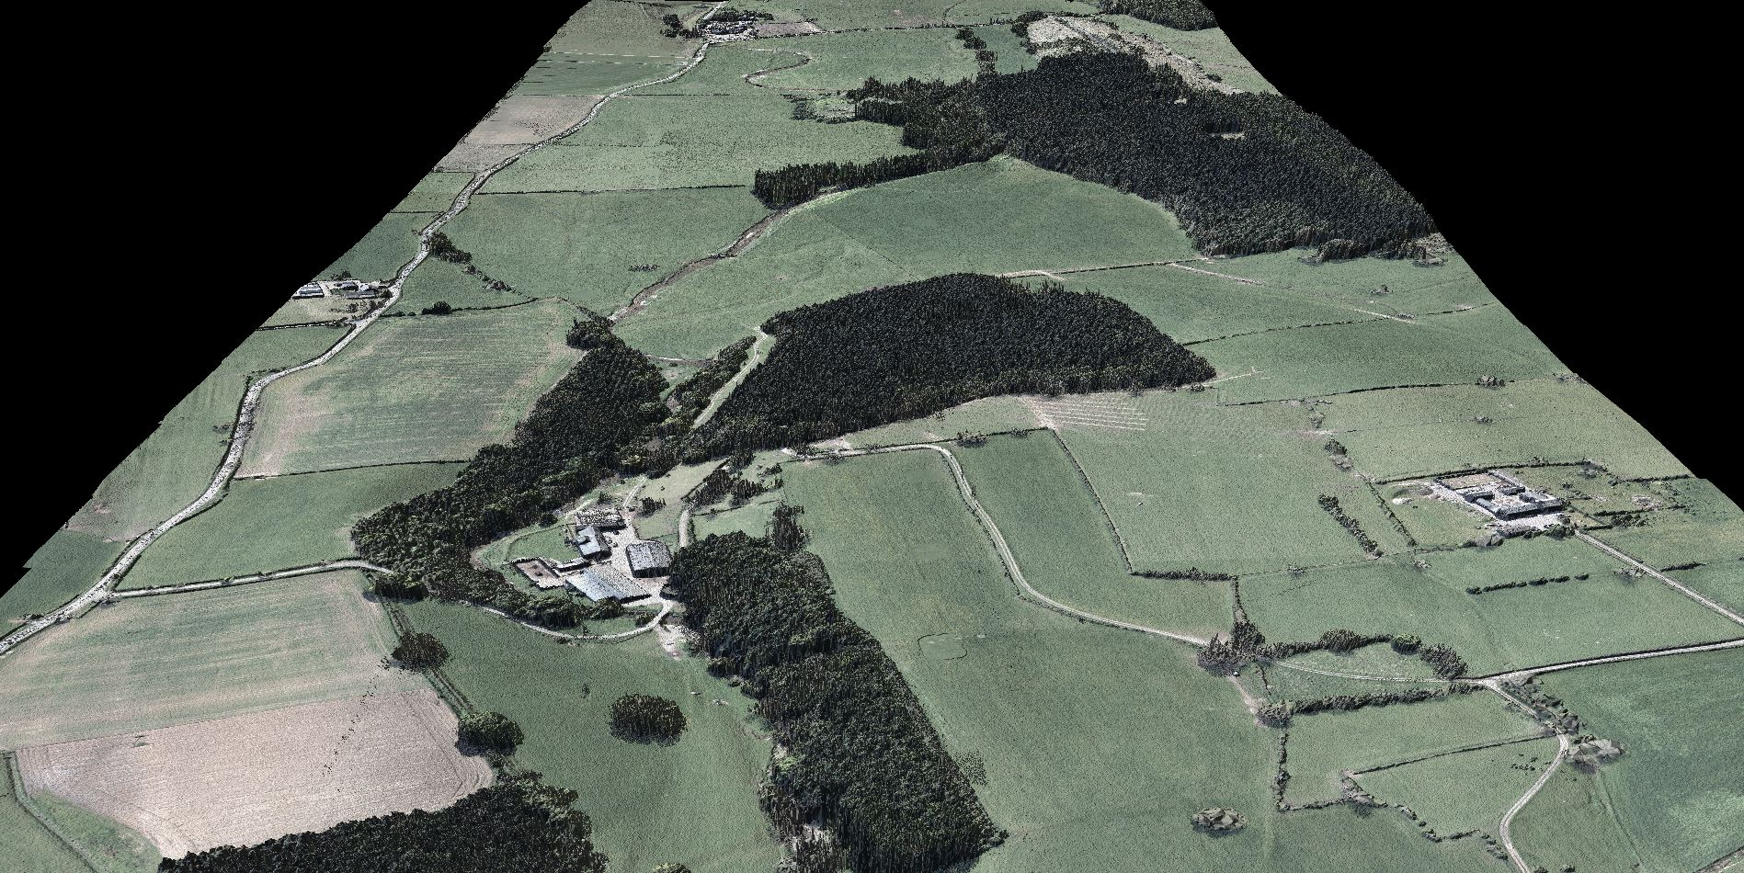

1. **River Lyvennet upstream of Barnskew**

