RIVER MANAGEMENT PLAN

Long River and Blackwater River

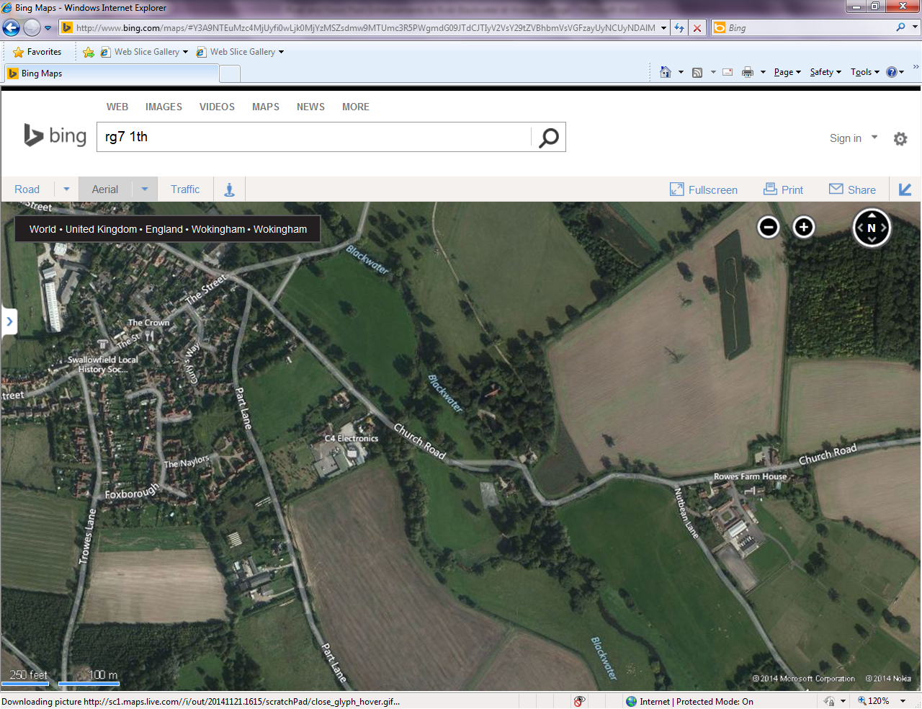

Wolsey Cottage, Church Road, Swallowfield, Berkshire, RG7 1TH

Author: Matt Drew B.Sc (Hons), MIFIM 0782 606 7939

Table of Contents
Location 4
Background 5
Long River Observations (Upstream Limit to Downstream Limit) 6
Blackwater River Observations (Upstream Limit to Downstream Limit) 10
Other Observations 11
Previous Habitat Enhancements or Works Carried Out 11
Proposed Habitat Enhancements and Works 13
Time Plan for Proposed Works 16
Proposed Method of Work 17
Appendix A – Supporting Diagrams, Notes and Glossary 23
Appendix B – Sources and Recommended Reading 26
Appendix C –Materials, Equipment, Suppliers and Costs 27
Appendix D – Correspondence 29

Table of Figures
Figure 1: Red shaded area shows extent of Wolsey Cottage river channel ownership. 4
Figure 2: Locations of the two gauging stations & weirs (A) and (B). 5
Figure 3: View from Gauging Station (B) downstream to weir pool (left). Weir pool and shallow water gravel riffle at downstream end of weir pool (right). 6
Figure 4: View from gravel riffle downstream to footbridge showing bare banks and over-shaded channel. 7
Figure 5: View from footbridge downstream showing over-shaded channel (left). View upstream showing un-vegetated marginal berm on right hand river bank (right). 7
Figure 6: View of channel downstream of footbridge towards berm on left hand river bank (left). View of berm on left hand river bank, trapezoidal channel and steep banks (right). 8
Figure 7: Over wide river channel just before backwater, showing in-channel emergent vegetation and vertical banks (left). Entrance to backwater on left hand river bank, showing silted up entrance and backwater beyond (right). 9
Figure 8: Marginal berm with vegetation which has developed on left hand bank, downstream of backwater entrance (left). Woody debris structures, marginal deposition and vegetation next to right hand bank, and main river channel around old island (right). 9
Figure 9: Exit of old left hand channel around the back of old island, showing bare banks and over-wide, over-shaded river channel (left). Windblown trees forming woody debris structures and increasing flow velocities within main river channel (right). 10
Figure 10: 1898 Ordinance Survey Map showing Blackwater River and Long River channels. 12
Figure 11: Overall design drawing showing installation sites. (NOT TO SCALE). 13
Figure 12: Using an excavator to push vertical banks into the channel, creating a more natural bank edge (left). River bank partially pushed into the channel by use of excavator, creating slack water and bank stability (right). 14
Figure 13: Grading banks to provide a two stage river channel for high flow events. 14
Figure 14: Low Cost Baffles installed on a crump weir at a Gauging Station. 15
Figure 15: Areas of the right hand river bank where over-shading has occurred and where tree works would be of benefit. 16
Figure 16: Existing river channel cross section. 18
Figure 17: Proposed river channel cross section with marginal cover, graded bank and high flow channel. 18
Figure 18: Proposed method of installing and securing woody debris items, faggots & bank protection. 19
Figure 19: Construction and installation of Large Woody Debris structure utilising anchor & trench in river bank. 20
Figure 20: Large Woody Debris item secured by stakes & wire with coir matting in background. 20
Figure 21: Woody Debris item secured using steel cable and tree stump anchor. 21
Figure 22: Method of assembling baffle structures and fitment to weir face. 22
Figure 23: Gravel cleaning using 2" pumps and venturi cleaners. 22
Figure 24: Schematic diagram of proposed Geotextile and faggot bank repair method. 23
Figure 25: Schematic diagram of proposed cut and fill bank repair method. 24
Figure 26: Schematic diagram of proposed Large Woody Debris installation and bank repair method. 24
Figure 27: Effects of Large Woody Debris Angles on flow and banks. 25
Figure 28: Schematic diagram of impression of finished channel with effects of installed enhancements. 25

Location
Street Address: Wolsey Cottage, Church Road, Swallowfield, Berkshire, RG7 1TH
National Grid Reference: SU 73207 64631
Upstream National Grid Reference: SU 73303 64499
Downstream national Grid References: SU 73014 64720 SU 73204 64670
Wolsey Cottage was purchased in November 2014 and is set in approximately 10 acres of pasture land on an island between the two channels of the Blackwater River, approximately 1.2 kilometres upstream of the Blackwater River and River Loddon confluence in Swallowfield Park. The Blackwater splits into two channels on the southern tip of the island at a gauging station. The Blackwater River upstream of the gauging station and the southern channel is known as, and referred to as the Long River. The northern (straighter) channel is known as and referred to as the Blackwater River, as is the main channel downstream of the confluence of the two channels in Swallowfield Park.
The Long River bank length of the grounds of Wolsey Cottage is approximately 450 metres on the southern and western edge of the island. There is also approximately 250 metres of the Blackwater River on the eastern edge, giving a total of approximately 650 metres of combined bank edge on both channels, downstream of the gauging station in both cases.
The Blackwater River flows from south to north, with the flow being split at the gauging station. The Long River takes approximately 40% of the flow, and the Blackwater River the remaining 60% approximately.
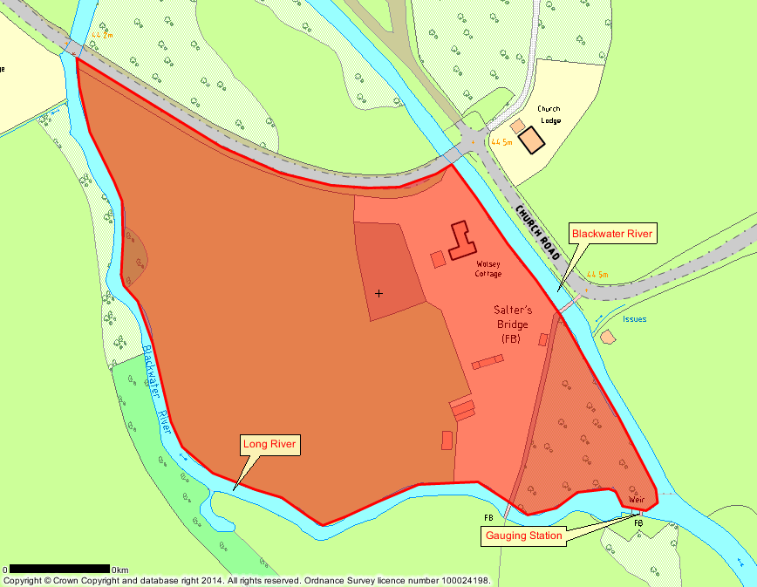
Figure 1: Red shaded area shows extent of Wolsey Cottage river channel ownership.

Background
Between the Blackwater River and River Loddon confluence 1.2 kilometres downstream and the southern tip of the Wolsey Cottage grounds, there are two gauging stations of the crump weir variety. Both gauging stations (including the weir structure and footbridges) are owned by the Environment Agency, and both are impassable to most cyprinid fish species at normal and low flows. In times of very high flows, some species may be able to pass upstream over the weirs. The gauging station in Swallowfield Park on the Blackwater River is referred to as (A) and the gauging station on the Long River at the southern tip of the Wolsey Cottage grounds is referred to as (B). Upstream of the Gauging Station (B), the Long River is over wide, perched, impounded, lacking in habitat and suffers from low flow velocities. Both Gauging Station structures and footbridges are legally owned by the Environment Agency.
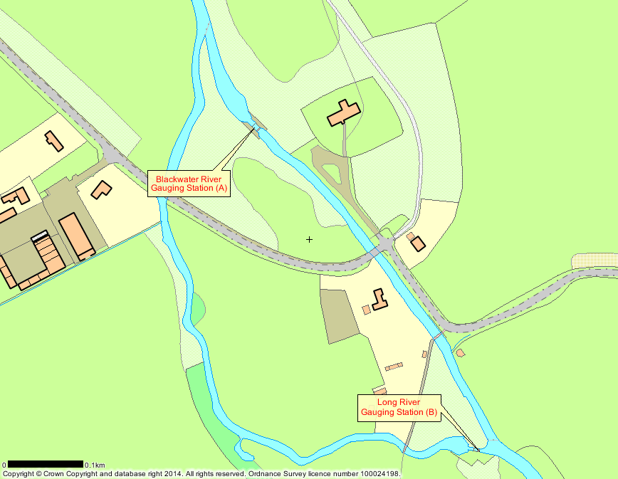
Figure 2: Locations of the two gauging stations & weirs (A) and (B).
Land Owner Contact: Phil Drew 0118 988 5533
Environment Agency Contact: Karen Twine 01252 729 571
Author Contact: Matt Drew 0782 606 7939

Historical Issues and Points
Previous dredging activity, over widening of the river channel, impounding, lack of fish passage, lack of juvenile habitat, land flooding, lack of land drainage, run off, deposition, lack of spawning substrate, turbidity.

Objectives
To improve habitat, fish passage, spawning and recruitment opportunities, native fish stocks and implement Water Framework Directive improvements to achieve Good Ecological Status within the catchment. Also, to decrease any risk of Wolsey Cottage flooding, improve the ecology and land use of the grounds and create sympathetic use of the pasture land.

Long River Observations (Upstream Limit to Downstream Limit)

Gauging Weir Structure and Weir Pool to Footbridge
Gauging station (B) is a crump weir type constructed from concrete, has a head to tail level difference of approximately 0.7 metres and a length of approximately 10 metres. The gauging weir constricts the flow and is impassable to most cyprinid fish species at normal flow levels. Downstream of gauging station (B), there is a small weir pool, with an old bagwork retaining wall on the right hand bank downstream of the weir structure for around 10 metres. This bagwork retaining wall has suffered from scour erosion to the rear of it, creating a void between the natural bank edge and the rear of the bagwork wall. In front of this bagwork wall are several fallen woody debris structures, predominantly willow, which have windblown and taken root in the edge of the weir pool.
The left hand bank is heavily overgrown, but the concrete weir structure extends to around 3m downstream of the tail of the weir sill. The right hand bank is predominantly bare earth graded down to the wet channel, with semi-mature willow and ash trees over-shading the bank and channel, preventing marginal and in-channel vegetation growth. At the downstream end of the weir pool is a large gravel riffle across the central 80% of the channel in approximately 0.3 metres of water at normal flow levels. The substrate within the weir pool would appear to be predominantly small to medium sized gravel, which has been compacted over time.
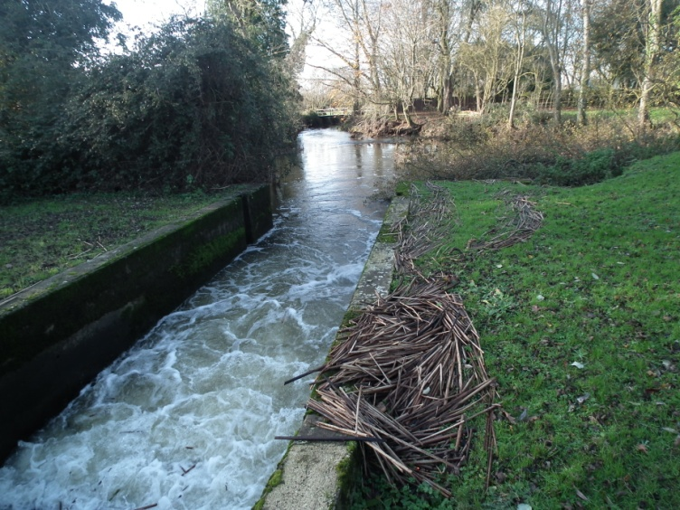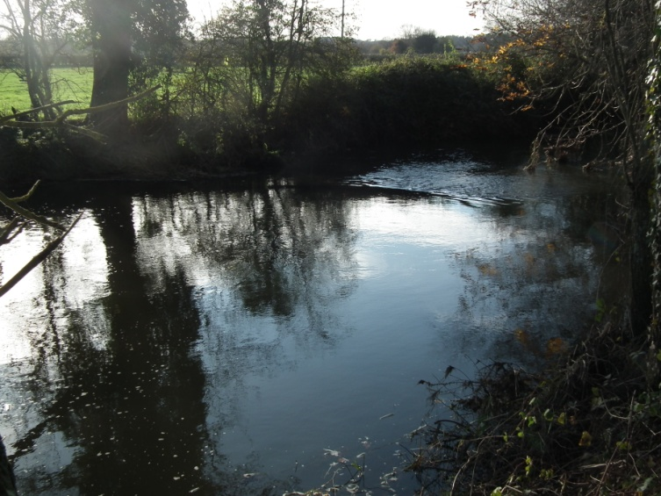
Figure 3: View from Gauging Station (B) downstream to weir pool (left). Weir pool and shallow water gravel riffle at downstream end of weir pool (right).
Downstream of this riffle, the channel narrows and deepens, and flow velocities increase as the channel meanders to the right. There is a single span concrete footbridge across the channel, carrying a public footpath. The right hand bank steepens away from the wet channel to vertical in places and is still over-shaded by semi-mature trees, preventing marginal and in-channel vegetation growth. Some marginal deposition has occurred over time, narrowing the wet channel and creating a small silt berm on the right hand river bank, just above normal flow height. This berm has not colonised with vegetation due to the over-shading effect of the trees. The berm has stabilised over time, but additional stabilisation from rooted vegetation and woody debris structures would be of benefit.
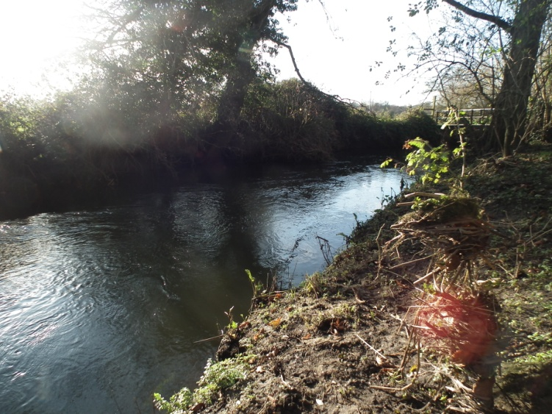
Figure 4: View from gravel riffle downstream to footbridge showing bare banks and over-shaded channel.

Footbridge to Backwater
Downstream of the footbridge on the right hand bank, further semi-mature trees over-shade the channel, although some in-channel vegetation growth is visible, and the bank steepens in places. In other places some deposition of silt has occurred, narrowing the channel and creating small, flatter marginal berms. These berms have not colonised with vegetation due to the over-shading effect of the trees. The berms have stabilised over time, but additional stabilisation from rooted vegetation and woody debris structures would be of benefit. Behind the berms, the bank is still steep and bare earth due to historic dredging and artificial river profiling, and flow velocities decrease from the footbridge downstream. The river channel is also over-wide and mostly trapezoidal with little or no in-channel morphology.
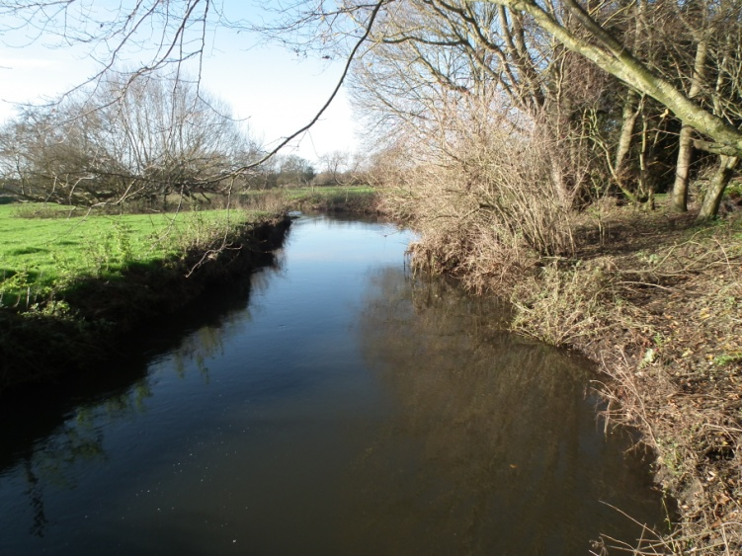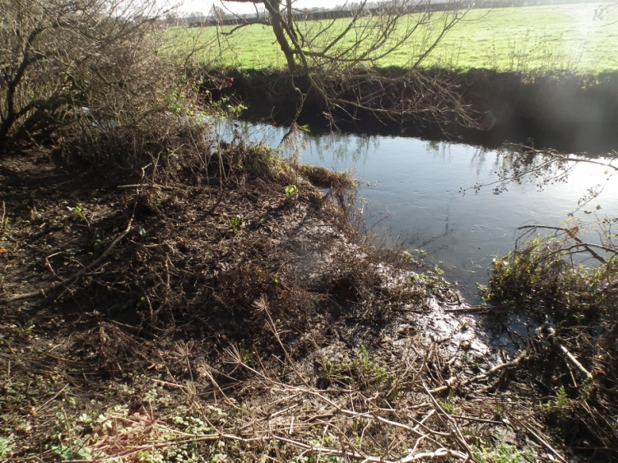
Figure 5: View from footbridge downstream showing over-shaded channel (left). View upstream showing un-vegetated marginal berm on right hand river bank (right).
Shortly downstream of the marginal berm and semi-mature trees, the pastureland begins with a scrub margin consisting mainly of nettles and brambles. The banks are vertical in most places and end approximately 0.5 metres above the normal water levels. There is a lack of in-channel and marginal vegetation, although another marginal berm on the left hand river bank has developed through deposition on the inside of a left hand meander. This berm has started to colonise with grass and nettles as there is little over-shading. The river channel is trapezoidal in nature, although some channel morphology is present with a left and right hand meander where the river has attempted to narrow itself through deposition, before a large backwater on the left hand river bank.
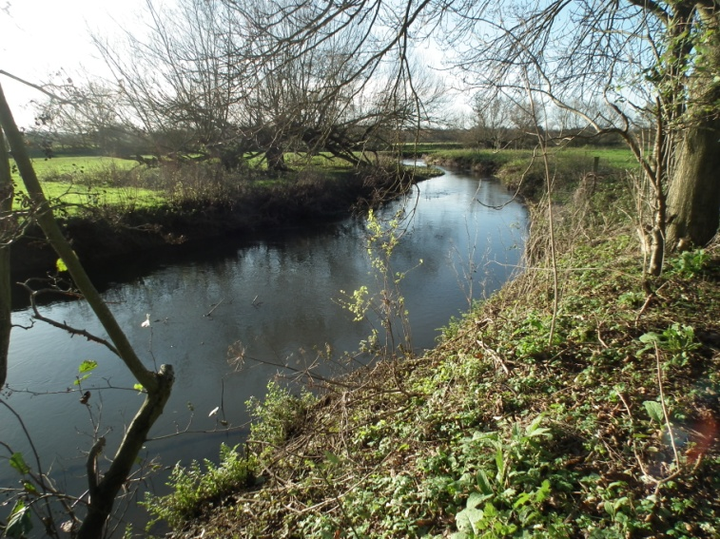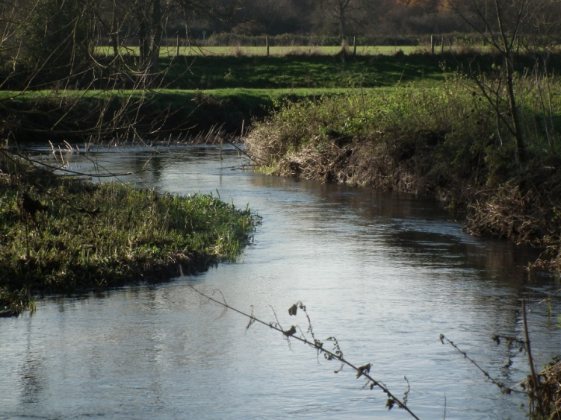
Figure 6: View of channel downstream of footbridge towards berm on left hand river bank (left). View of berm on left hand river bank, trapezoidal channel and steep banks (right).
Downstream of the berm on the left hand river bank, the river channel meanders to the right before straightening out again. The channel is again vertical banked, over-wide and trapezoidal, with a silt substrate. In-channel emergent vegetation (Club Rush - Schoenoplectus lacustris) is present across the channel, providing habitat, but also reducing flow velocities and causing deposition. This species is indicative of low velocity flows, as it fails to grow and spread in faster moving water. There is little or no marginal vegetation due to the vertical banks. Evidence of crayfish burrowing is visible on the left hand river bank. The bankside vegetation is again predominately nettles and brambles, with one or two semi-mature willow trees which require managing. On the left hand river bank is a large backwater (See Figure One and Figure Seven), with a small entrance off the main river channel. The entrance to this backwater has silted up and semi-vegetated over time, preventing fish access to rest out of the main channel in times of high flows. The land on which this backwater is situated is not currently under the ownership of Wolsey Cottage.
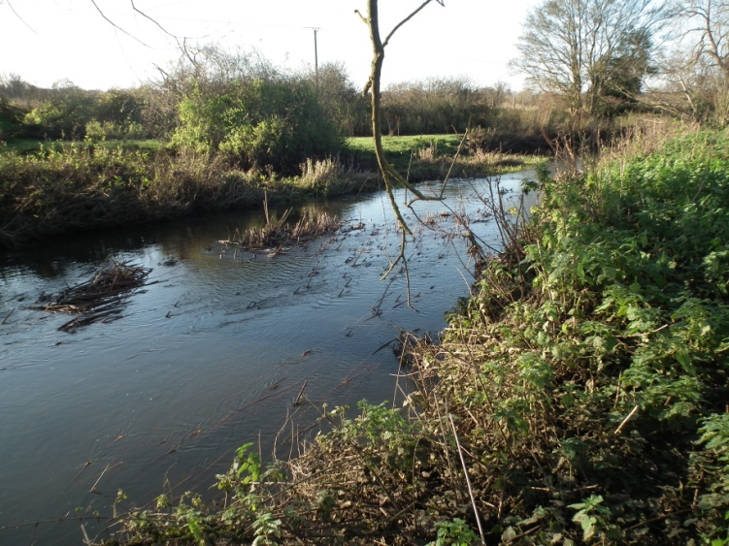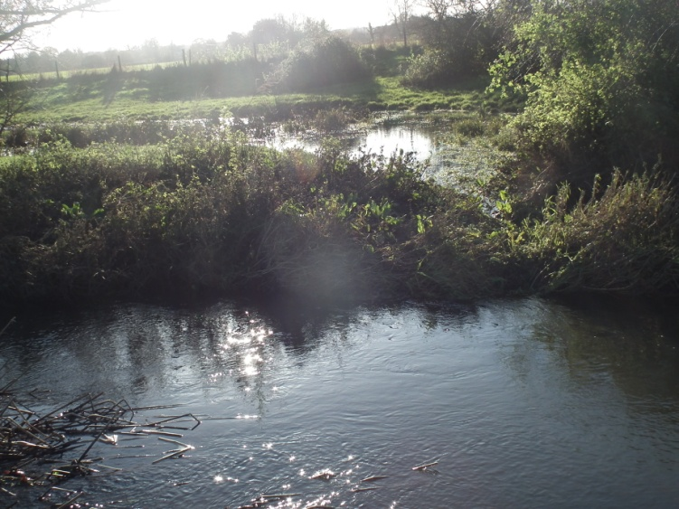
Figure 7: Over wide river channel just before backwater, showing in-channel emergent vegetation and vertical banks (left). Entrance to backwater on left hand river bank, showing silted up entrance and backwater beyond (right).

Backwater to Island
Immediately downstream of the backwater, on the left hand river bank, another marginal berm has started to develop through deposition. This has narrowed the river channel and created an increase in flow velocities along the right hand river bank. There is little or no marginal vegetation due to the vertical banks again. The bankside vegetation is again predominately nettles and brambles, with one or two semi-mature willow trees which require managing. Downstream of this berm, the channel is again vertical banked, over-wide and trapezoidal, with a silt substrate and low flow velocities, and becomes over-shaded again by semi-mature tree cover, predominantly willow. At this point the channel used to split and flow around a small island, however the second channel (around what would have been the left hand side of the island) has silted up over time, and the river only uses this channel in high flows. The island forms part of the grounds of Wolsey Cottage but is inaccessible except from the left hand river bank or by boat. This island is not shown on modern maps but the exit of the old left hand channel around the back of the island can be seen. Marginal deposition close to the right hand river bank has provided a silt berm just below the normal water level, which has started to colonise with marginal vegetation. Downstream of this berm, the channel is again vertical banked, over-wide and trapezoidal, with a silt substrate and low flow velocities, and becomes heavily over-shaded again by semi-mature and mature tree cover, predominantly willow. Several trees have become windblown and dropped into the river at this point as woody debris structures, providing habitat and cover, and watercress has started to colonise one or two of the structures.
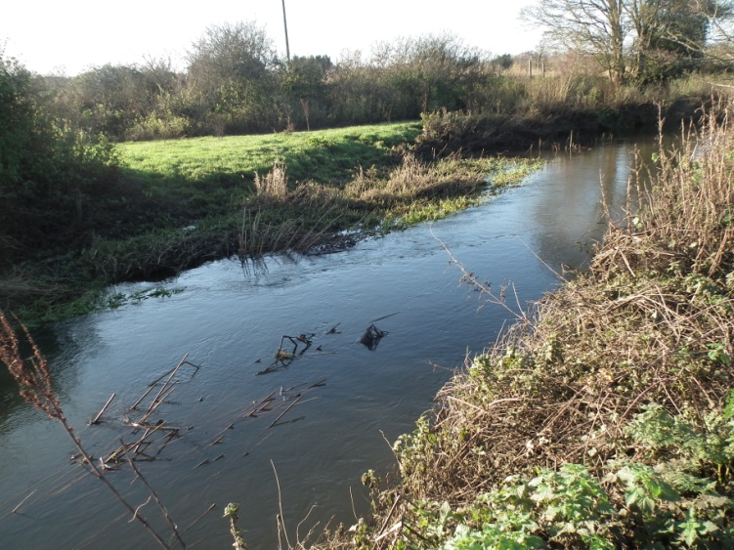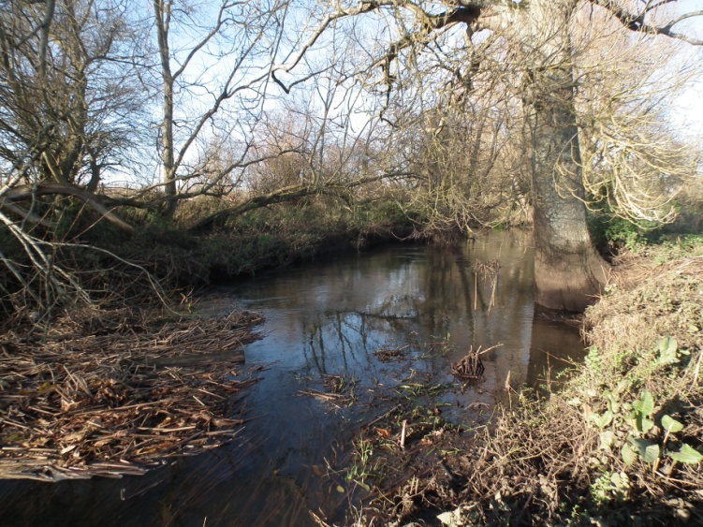
Figure 8: Marginal berm with vegetation which has developed on left hand bank, downstream of backwater entrance (left). Woody debris structures, marginal deposition and vegetation next to right hand bank, and main river channel around old island (right).

Island to Church Road Bridge
From the downstream tip of the old island, the exit of the old channel can be seen, and the main river channel is heavily over-shaded again by semi-mature and mature tree cover, predominantly willow. These trees require managing to prolong their life span. Several trees have become windblown and dropped into the river at this point as woody debris structures, providing habitat and cover, and watercress has started to colonise one or two of the structures. One structure has formed a partial barrier across the channel, and is causing some erosion of the right hand bank, due to the channel having little or no marginal vegetation due to the vertical banks again. The bankside vegetation is again predominately nettles and brambles, with one or two semi-mature willow trees which require managing. The channel is again vertical banked, over-wide and trapezoidal, with a silt substrate and low flow velocities, although the flow has increased due to the woody debris structures which have formed in the channel as a result of windblown trees and trapped debris. However, these woody debris items are not secured, but have started to take root and colonise. Some management of these, combined with bank management could provide in-channel cover, and increase flow velocities.
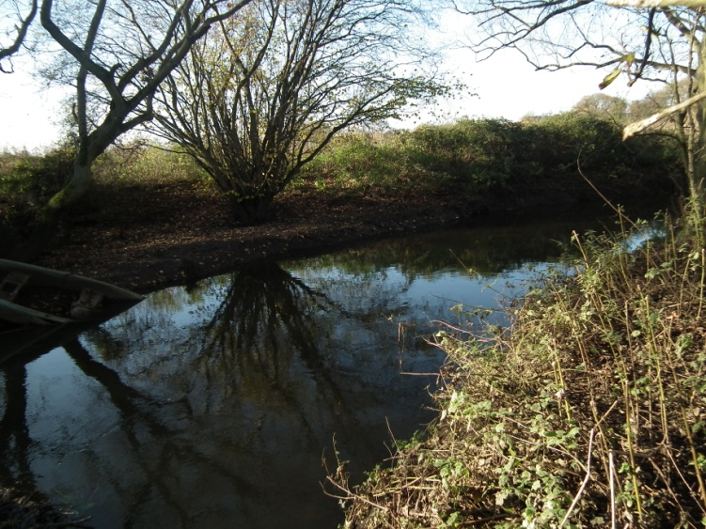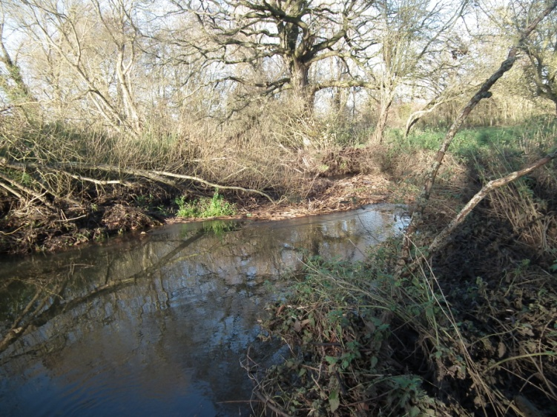
Figure 9: Exit of old left hand channel around the back of old island, showing bare banks and over-wide, over-shaded river channel (left). Windblown trees forming woody debris structures and increasing flow velocities within main river channel (right).

Blackwater River Observations (Upstream Limit to Downstream Limit)

Gauging Weir Structure to Footbridge
The Blackwater River at the south eastern tip of the island is impounded by the effect of both Gauging Station (A) and (B), and is extremely lacking in hydromorphology as a consequence of both the weirs and a very straight and trapezoidal channel. The main river channel is heavily over-shaded again by semi-mature and mature tree cover, particularly from the left hand bank. The channel appears to be deep and has hard bank revetments installed for some of the length of the left hand bank, although this revetment does increase the flow by narrowing the channel for around 12 metres. Downstream of this revetment, the channel is again vertical banked, over-wide and trapezoidal, but it shallows and becomes heavily over-shaded again by semi-mature and mature tree cover. The left hand bank is predominantly bare earth, resulting in some erosion and slippage over time. The gravel substrate has degraded overtime, becoming concreted and deposition has occurred due to low flow velocities, decreasing the amount of substrate available for spawning.

Footbridge to Church Road Humpback Bridge
From the footbridge downstream the channel is extremely lacking in hydromorphology as a consequence of both the weirs and a very straight and trapezoidal channel. The right hand bank has been sheet piled for some distance to prevent erosion under the Church Road bend adjacent to the footbridge. The main river channel is heavily over-shaded again by semi-mature and mature tree cover, particularly from the left hand bank. The channel appears to be deep and has hard bank revetments installed for some of the length of the left hand bank, although this revetment does increase the flow by narrowing the channel for around 12 metres. Downstream of this revetment, the channel is again vertical banked, over-wide and trapezoidal, but it shallows and becomes heavily over-shaded again by semi-mature and mature tree cover. The gravel substrate has degraded overtime, becoming concreted and deposition has occurred due to low flow velocities, decreasing the amount of substrate available for spawning.

Other Observations

Non-Native and Invasive Species
As far as the author is aware, there are no invasive species of animal, fish or fauna within the river channel within the grounds of Wolsey Cottage. It is highly likely that there is a resident population of American Signal Crayfish (Pacifastacus leniusculus) within the Long River and Blackwater River, as crayfish burrows can be seen within the clay river banks in some locations. There has also been historically a population of American Mink (Neovision vision) within the grounds of Wolsey Cottage which may be eradicated by systematic trapping and humane dispatching of any captured Mink.

Access for Vehicles, Heavy Plant and Equipment
Access to the right hand river bank of the Long River is possible along the entire length of the channel under the ownership of Wolsey Cottage. Access to the majority of the left hand river bank of the Blackwater River is possible from the grounds of Wolsey Cottage, although there is dense and tall vegetation along most of the bank. A public footpath / right of way crosses the grounds of Wolsey Cottage, crossing the Blackwater River, dissecting the grounds and then crossing the Long River approximately 100 metres downstream of the Gauging Station (B) (See Figures One and Two). Access for the delivery of materials by HGV, heavy plant and equipment is possible from Church Road, Swallowfield into the pasture land through a five bar gate off the road. There is no formal road or track across the pasture land, and due consideration should be given to ground conditions. Access to the small area of land on the eastern side of the footpath and the left hand bank of the Blackwater River is achieved through two large gates either side of the footpath at the southern end of the land. There is plenty of operating room along both river banks for a large excavator (See Appendix C – Required Materials, Equipment and Costs) to be used for the majority of the proposed work.

Overhead and Underground Utilities
To the authors knowledge, there are no overhead or underground utilities present on the site with the exception of the below.
- A single telephone wire from a telephone pole on Church Road, travelling across the northern boundary of the grounds and into the north facing wall of Wolsey Cottage.
- Various blue plastic irrigation pipes carrying water supplies, notably around the area of the horse ménage, existing stables and existing barn, some of which may be underground.
- Various domestic 240v power supplies to the summerhouse, existing outbuildings, sheds, barn, stables and ménage. The location and underground depth of these 240v supplies is not known.

Previous Habitat Enhancements or Works Carried Out
The author is not aware of any previous works to the river channel or banks owned by Wolsey Cottage. However, an Ordinance Survey Map dated 1898 clearly indicated the river channel at the location has been modified (See Figure Ten), by the removal of several distributary channels and the creation of a single river channel with the gauging station (B). Two old islands on the Long River channel to the west of the land, with two channels around them are also visible. Neither island is shown on modern Ordinance Survey maps. The original main channel split between the Long River and Blackwater River was slightly north of the current location, but has been infillled (presumably at the same time as the current channel split and Gauging Station (B) was constructed), and an irrigation channel across the fields to the south (on land not under the ownership of Wolsey Cottage) has also been infillled at some point in the past.
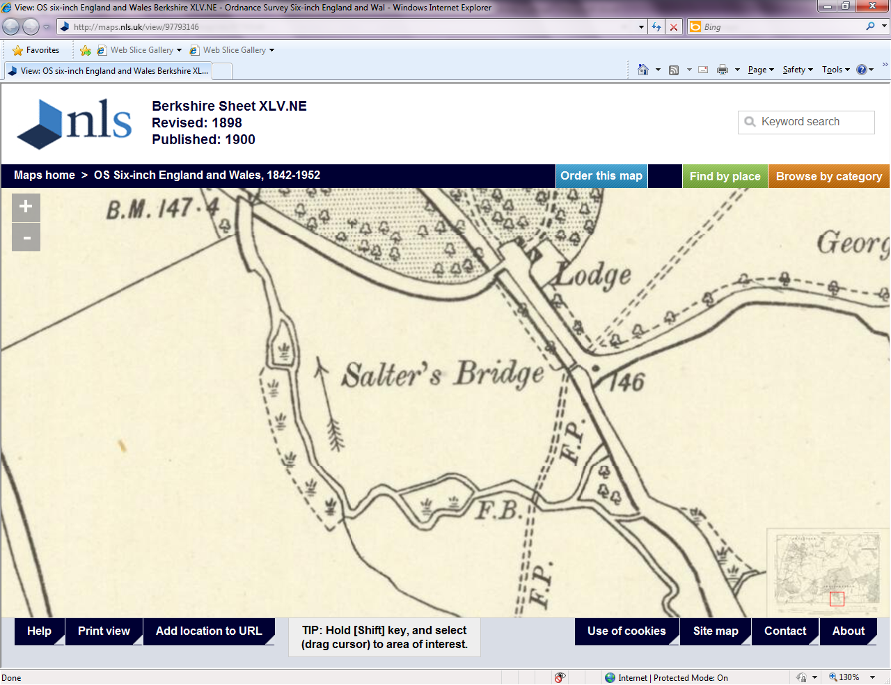
Figure 10: 1898 Ordinance Survey Map showing Blackwater River and Long River channels.

Proposed Habitat Enhancements and Works
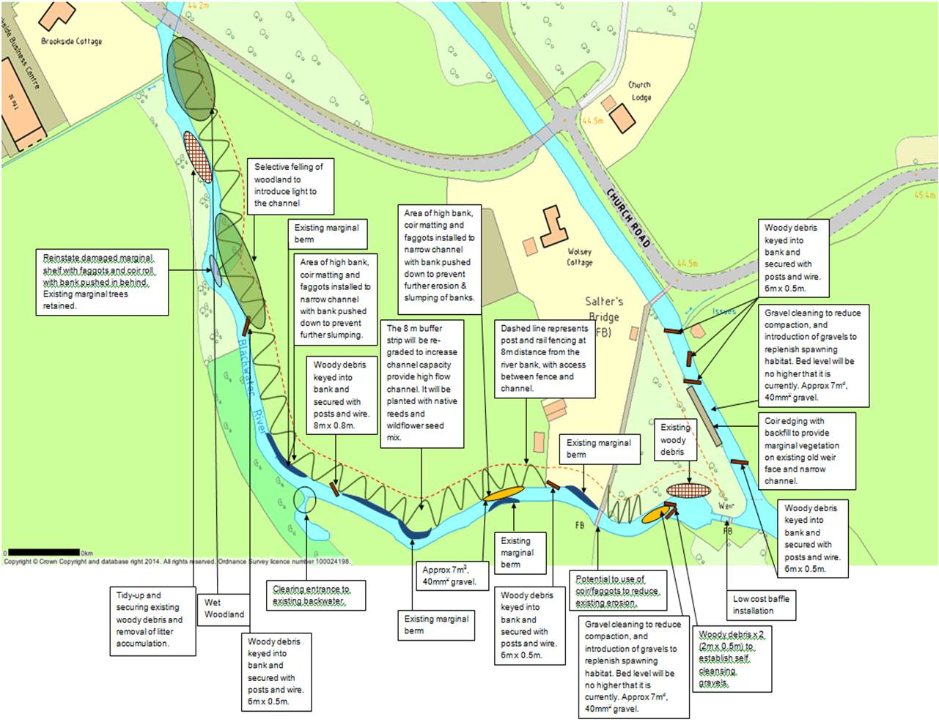
Figure 11: Overall design drawing showing installation sites. (NOT TO SCALE).

Land Grading
To grade the existing pasture and paddock land gently down to the river channel to improve land drainage, minimise silt run-off and allow water to drain effectively back into the river channel after high flow events. Surface water land drainage using perforated plastic pipe and 40mm² gravel rejects would also be down the graded slope to further aid drainage, and prevent run-off from entering the river channel. As part of this work, some stumps and debris from previously felled trees will be removed from the ground. This work would be combined with reconnecting the river and banks. An 8m buffer zone along the right hand river bank of the Long River would be left to colonise naturally with native wild meadow plants and marginal aquatic vegetation. Post and three rail fencing would be installed along the edge of this buffer zone, 8m from the river bank to prevent livestock access to the river, whilst retaining enough distance between the fencing and the edge of the Long River channel to allow access with plant or vehicles to carry out maintenance without causing channel disturbance.

Reconnecting River and Banks
The current Long River channel is trapezoidal for much of the length, and the banks are generally steep, bare and set high above the normal water level due to historic modifications and dredging. The right hand river bank would pushed into the channel for most of the length (See Figure Eleven), creating a sloping bank profile, slack water, shallow water and marginal habitat, preventing erosion and allowing marginal vegetation to colonise the bank, ensuring long term bank stability. The addition of Large Woody Debris pinned under the new bank edge and in-channel would be utilised in areas where the risk of erosion is increased to provide further bank support.
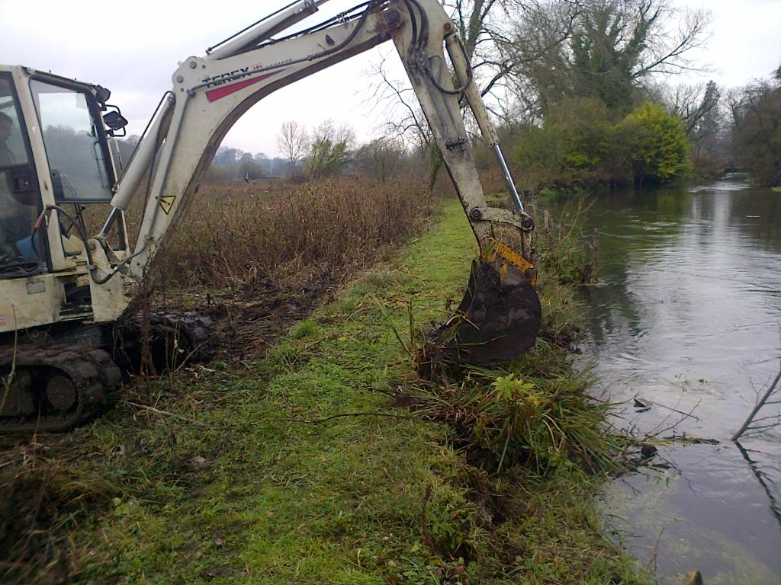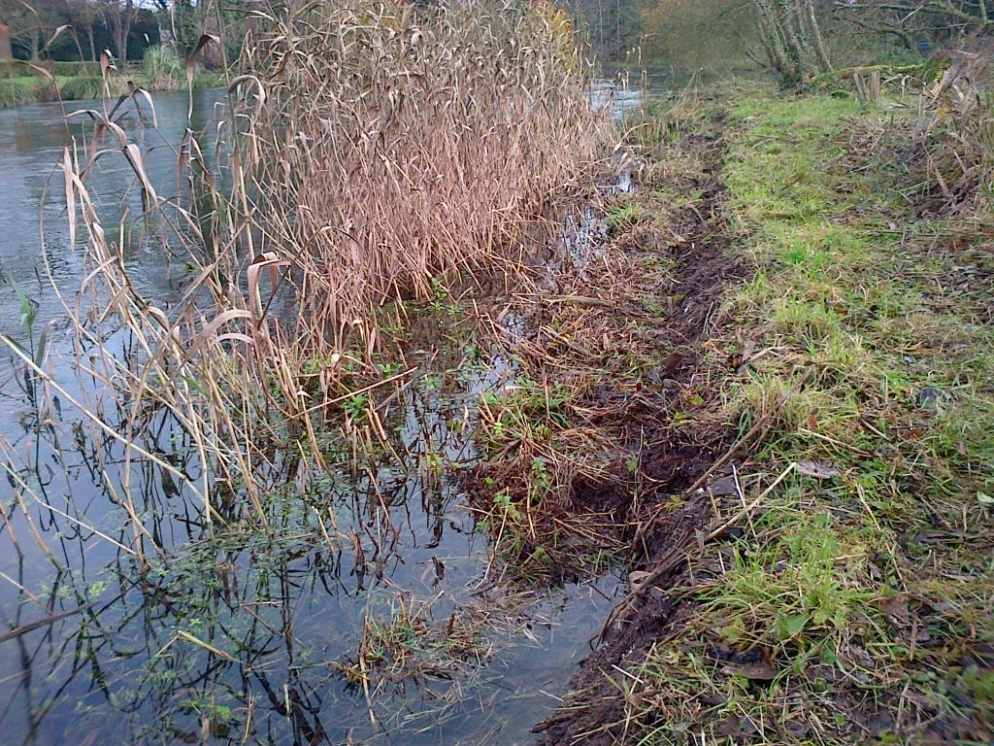
Figure 12: Using an excavator to push vertical banks into the channel, creating a more natural bank edge (left). River bank partially pushed into the channel by use of excavator, creating slack water and bank stability (right).

Creating a two stage channel (High Flow / Low Flow)
Use the existing wet channel as a low flow channel (once the river banks have been reconnected to the river), and utilise the grading of the field to create a gently sloping high flow channel to prevent the river over-topping the banks and isolated pools occurring in the pasture land on the southern and western edge of the grounds, where ground undulations create low spots where water and potentially fish can pool after high flow events. (See Figure Twelve). This would improve land drainage, and also retain or increase flood plain capacity by allowing water to store within the high flow channel as the road bridge at the downstream limit of the Long River acts as an artificial constriction to the amount of water which is capable of passing under it. It would not be necessary to utilise pre-planted coir rolls, but the use of willow or hazel faggots to provide submerged support and prevent erosion is suggested. It may be possible to construct the faggots on site from the various stands of Willow.
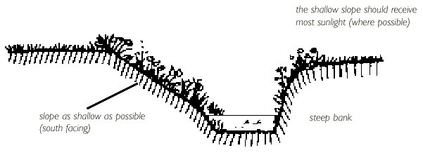
Figure 13: Grading banks to provide a two stage river channel for high flow events.

Fish Passage Easement on Gauging Station
The crump weir at Gauging Station (B) is impassable to fish in all but the highest flows. The weir cannot be removed due to the high use for flow data recording, and the maintaining of river levels upstream and over Gauging Station (A). Low cost baffles could be fixed to the crump weir face to ease fish passage over the weir and improve fish stocks on the Blackwater River and Long River up and downstream of the weir. (See Figure Thirteen). These baffles would be supplied by the Environment Agency and installed by the owners of Wolsey Cottage with assistance and guidance from the Environment Agency Fisheries team. Consultation with Environment Agency Hydrometry and Telemetry staff would be required prior to any work taking place on or downstream of the crump weir and some use of Environment Agency equipment to prevent environmental incidents would also be required.
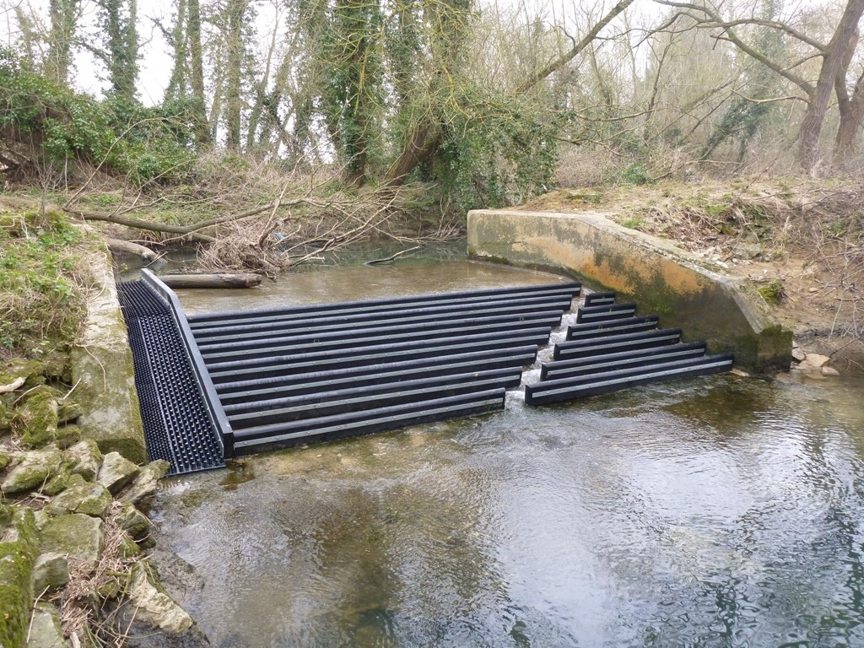
Figure 14: Low Cost Baffles installed on a crump weir at a Gauging Station.

Reducing Over-shading and Installing Woody Debris & Spawning Habitat
Currently there are various locations along the Long River channel where excessive tree growth has caused over-shading. (See Figure Fourteen). These areas are predominantly on the western edge of the grounds, upstream of the Church Road road bridge. This over-shading has resulted in bare banks, increased erosion, and a lack of marginal and in-channel vegetation, resulting in poor ecology. The tree species along the right hand river bank are predominantly semi-mature willow trees, with occasional smaller Elderberry trees. These trees require pollarding or felling to maximise their life span. The timber generated by the pollarding or felling could be used to improve in-channel habitat by installing Large Woody Debris, Coarse Woody Debris, marginal brush habitat, and soft bank protection along the right hand river bank, in conjunction with reconnecting the river and banks and creating a two stage channel. Where possible, smaller species (particularly none native species) should be felled, and more mature species pollarded. As part of the installation of Woody Debris items, it is proposed that a total of fifteen cubic metres of 40mm² gravel will be introduced to the river to provide an increase in spawning habitat for native coarse fish species in two or three locations. The existing gravel riffle downstream of Gauging Station (B) is extremely compacted and offers little viable spawning opportunity. The riffle would benefit from some gravel cleaning and loosening by aerated water jets and / or sympathetic use of an excavator to loosen the substrate to a depth of around 150mm and an introduction of gravel to supplement the existing substrate.
Currently there are various locations along the Blackwater River channel where excessive tree growth has caused over-shading. These areas are predominantly on the eastern edge of the grounds, upstream of the Church Road humpback bridge and the pedestrian foot bridge. This over-shading has resulted in bare banks, increased erosion, and a lack of marginal and in-channel vegetation, resulting in poor ecology. The tree species along the left hand river bank of the Blackwater River are predominantly semi-mature and mature Holly trees, with one or two specimen mature Oak trees. The river channel and bank would benefit from sympathetic felling and removal of the large mature Holly trees is suggested, at a height of around 1.5 metres. This should allow more light into the watercourse to encourage bankside, marginal and submerged weed growth. It should also allow the Holly to support fresh growth at a height of 1.5 metres, creating a hedge for privacy to the property. Smaller stands and stems of Holly can be hedge laid in the traditional manner to encourage growth and hedge thickness. Holly is not suitable for use in watercourses as woody debris structures, and it is suggested that the timber generated from this works be chipped, logged or burnt on site.
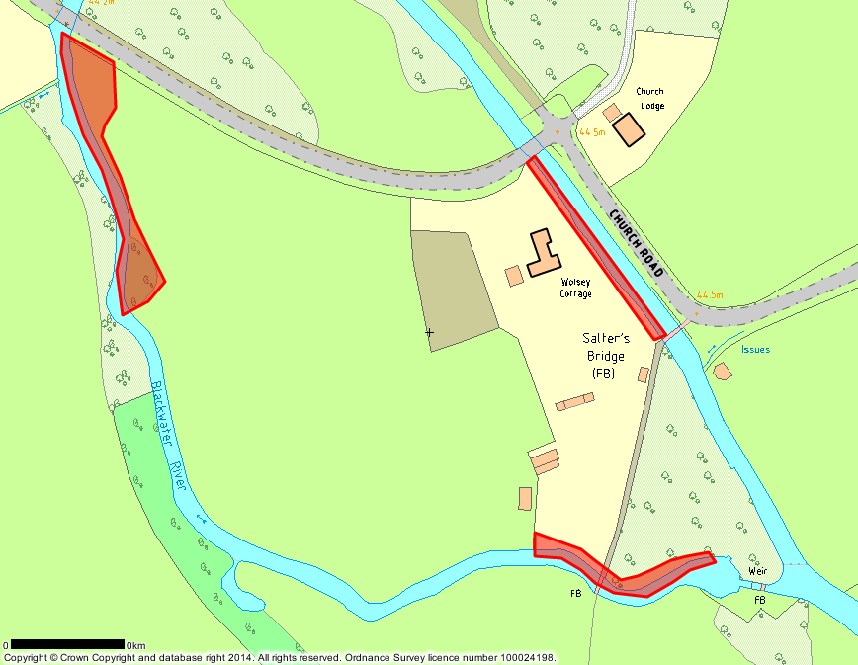
Figure 15: Areas of the right hand river bank where over-shading has occurred and where tree works would be of benefit.

Stock Fencing and Buffer Margin
The land along the right hand river bank is rough scrub, predominantly covered in nettles and of low ecological value. This scrub land would be graded, and a buffer zone of eight metres between the pasture land and the start of the low flow channel would be left to colonise with native wild plants. Post and rail fencing would be erected along the top edge of this buffer zone to prevent poaching by livestock. The buffer zone would also act as a filtration system during heavy rain, to reduce the amount of silt from entering the water course. Access by pedestrians and vehicles would be possible along the buffer zone to carry maintenance and allow fishing access.

Time Plan for Proposed Works
It is proposed that this work start in the planning stage from mid-December 2014, as any river or ground works during the winter months are likely to be delayed by high flows, inclement weather and unstable ground conditions. Work where there is a foreseeable risk of silt disturbance and consequent increased turbidity within the river should be confined to a minimum, and should be undertaken prior to mid-March 2015 to prevent any impact on coarse fish spawning and potential offences which could be committed as a result of any impact.
Any tree works (dismantling, climbing, felling and hedge laying) should be undertaken prior to the end of March 2015 to prevent any impact on the nesting of wild birds and potential offences which could be committed as a result of any impact.
December 2014 Undertake tree survey and mark trees for sympathetic felling & removal.
Engage with local authority, flood forum, angling club & land owners.
January 2015 Undertake sympathetic pollarding, felling & removal of selected trees.
Undertake hedge laying & coppicing along Blackwater River bank.
Apply for Environment Agency Flood Defence Consent for river works.
February 2015 Mark out areas of bank for enhancement works & low areas in paddocks.
Mark out locations of woody debris installation & gravel riffle introduction.
March 2015 Undertake grading & bank works with excavator along Long River.
Undertake tree felling & removal along Long River utilising excavator.
Install Woody Debris items & bank protection with excavator on Long River.
Undertake tree felling & pollarding alongside field edge in centre of land.
Backfill damaged area of bagwork wall downstream of gauging station.
Install marginal planting in specified areas of bank reinstatement.
July 2015 Undertake tree felling & pollarding in Weir Pool paddock and Blackwater River.
August 2015 Install Woody Debris items & in-channel features along Blackwater River channel.
Undertake gravel cleaning and gravel raking in Blackwater River channel.
September 2015 Undertake electro-fishing survey on both Long River and Blackwater River.
Undertake otter survey on both Long River and Blackwater River.
Undertake minor bank works on Blackwater River channel.

Proposed Method of Work

Land Grading
Utilising a 13t (approximate size) tracked 360 excavator and 5t (approximate size) four wheel drive dumper to grade the existing pasture land (including areas within 8m of the river bank) by sympathetically removing small high areas and infilling low areas with the resulting spoil. Some areas of bank protection may be infillled using the same spoil. No spoil will be removed from site. All plant will be kept a minimum of 1.5 metres from the watercourse edge and no plant will enter the watercourse. No disturbance to the river bed or substrate is to take place. Any excess material as a result of the grading will be removed from the flood plain and level to a depth of no more than 100 millimetres within the grounds of Wolsey Cottage.

Reconnecting River and Banks and Creating Graded Two Stage Channel
Utilising a 13t (approximate size) tracked 360 excavator and 5t (approximate size) four wheel drive dumper to push the existing bank into the river channel, from a distance of around 1m away from the sheer bank edge, creating a gently sloping bank edge and removing the steep, bare bank. In some areas it may be necessary to install hazel or willow faggots parallel to the bank edge in the watercourse prior to pushing the banks in to provide support to the bank and prevent further erosion or slumping. Some grading of the bank will take place in places to create the two stage channel (of around 8m in distance from the edge of the low flow channel to the edge of the high flow channel). Some areas of bank protection may be infillled using the same spoil. (See Figure Twelve). No spoil will be removed from site. All plant will be kept a minimum of 1.5 metres from the watercourse edge and no plant will enter the watercourse. No disturbance to the river bed or substrate is to take place. Any excess material as a result of the grading will be removed from the flood plain and levelled to a depth of no more than 100 millimetres within the grounds of Wolsey Cottage.

Figure 16: Existing river channel cross section.

Figure 17: Proposed river channel cross section with marginal cover, graded bank and high flow channel.
Both of the above works in combination should be completed in around 7 – 10 days and work would be timed to complete prior to 15th March 2015 to reduce or remove any impact on migrating or spawning fish.

Installation of Bank Protection, Woody Debris & Marginal Cover
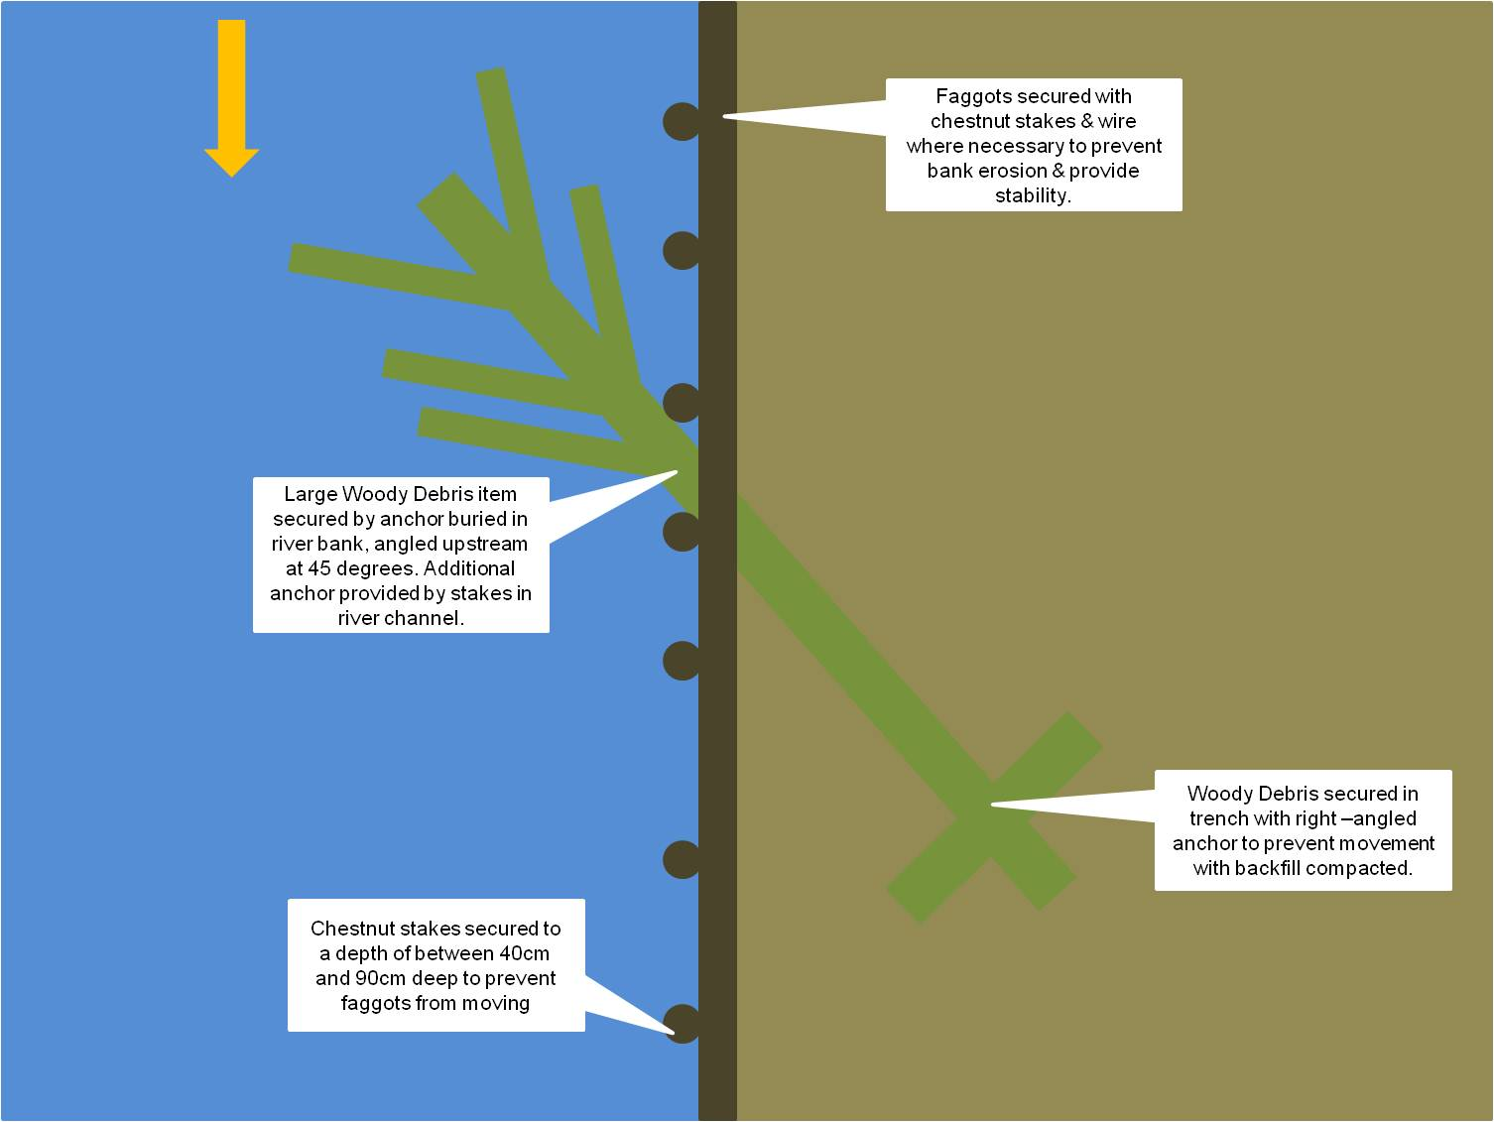
Figure 18: Proposed method of installing and securing woody debris items, faggots & bank protection.
Utilising timber generated on site, some woody debris items will be installed (subject to the conditions of the Environment Agency Flood Defence Consent) utilising a tracked 360 excavator. Large Woody debris will be secured by creating an anchor point at the stump end of the woody debris. This is done by wiring a smaller (circa 1m long) length of timber to the woody debris item, digging a trench of a suitable size into the river bank, installing the woody debris item and backfilling the trench (See Figure Eighteen and Figure Nineteen). All Large Woody Debris items are likely to be angled at 90 degrees to the bank, or at 45 degrees to the bank in an upstream direction to minimise bank erosion. In areas on the insides of meanders, some coir matting may be used to prevent bank erosion and allow the new bank edge to vegetate (See Figure Twenty).
Using geotextile or coir matting, bank protection can also be installed using ‘cut and fill’ techniques. Drive 1.8m long wooden stakes 60 – 90cm deep into the river bed, spaced approximately 30 – 50cm apart along desired new bank edge. Lay geofibre netting along and behind the wooden stakes, and secure each end to the inside of the existing bank with 30cm long wooden pegs hammered into the bank (if possible). Trim off any excess geofibre netting. Lay the geotextile material along the posts (inside the geofibre net), fold the bottom of the material onto the river bed and line behind the posts from bank to bank. Then use 30cm long wooden pegs hammered into the river bed to secure the loose geotextile material (if possible). Fold in the excess material at each end (approximately 60 – 90cm) to the bank, secure with 30cm long wooden pegs hammered into the bank inside backfill area (if possible) and backfill with material between the new bank edge and existing bank edge. Fold excess geotextile material from the top of the posts onto the top of the new bank and bury under backfill or secure with 30cm long wooden pegs hammered into the new bank created by the backfill (if possible). Trim wooden stakes to the desired height cut off / remove any excess geotextile material. Cover top layer of geotextile material with backfill and compact where possible.
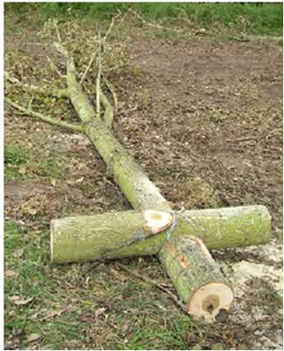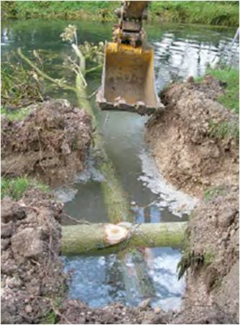
Figure 19: Construction and installation of Large Woody Debris structure utilising anchor & trench in river bank.
The chosen item of Woody Debris is cut, and then manoeuvred into the desired position (dependent on what result is required – scour, flow deflection, habitat or bank protection). The Woody Debris can then be secured by partially driving chestnut stakes into the river bed and wiring between the stakes and over the Woody Debris with fencing wire. The wire can then be pulled taut safely by driving the chestnut stakes further into the river bed. This method is particularly suitable for rivers with deep silt, as the chestnut stakes provide a more secure hold in silt than metal rebar pins.
Alternatively, once the Woody Debris is in position, vertical holes of a suitable diameter (19mm) can be drilled through the Woody Debris using the Stihl Wood Auger, and 16mm diameter metal rebar driven through the holes and into the river bed to secure the Woody Debris. This method is more suitable for rivers with gravel substrate, as the rebar pins are easier to drive into gravel than chestnut stakes. The Woody Debris can then be trimmed if required to avoid blockages.
These techniques can be used to create habitat, scour logs, submerged logs, flow deflectors, woody debris islands, and bank protection.
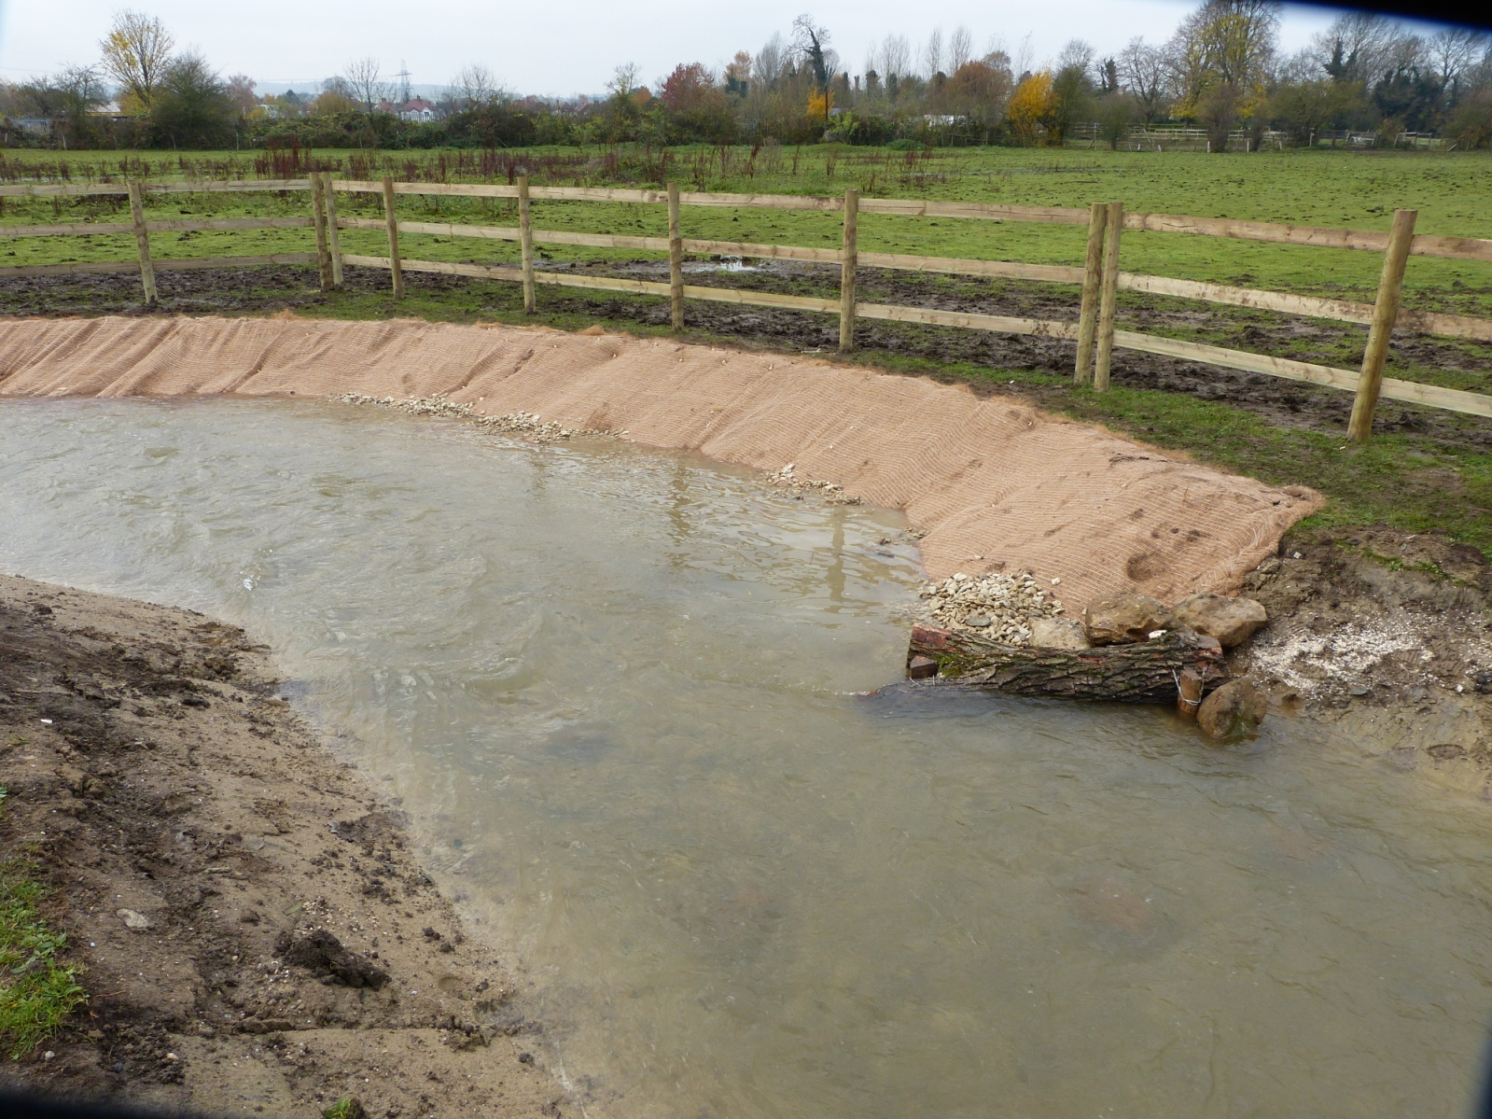
Figure 20: Large Woody Debris item secured by stakes & wire with coir matting in background.
The Woody Debris can also be secured by drilling holes of a suitable diameter (10 – 20mm) through the butt of the Woody Debris using the Stihl Wood Auger. Steel cable of an appropriate diameter (5mm – 10mm) is threaded through the drilled hole and around or through base or roots of adjacent trees, before being anchored and connected back on itself using cable clamps. Woody Debris is then orientated downstream along margins and / or staked into position, as above, if instream scour / refuge is desired. The Woody Debris can then be trimmed if required to avoid blockages. (See Figure Twenty One).
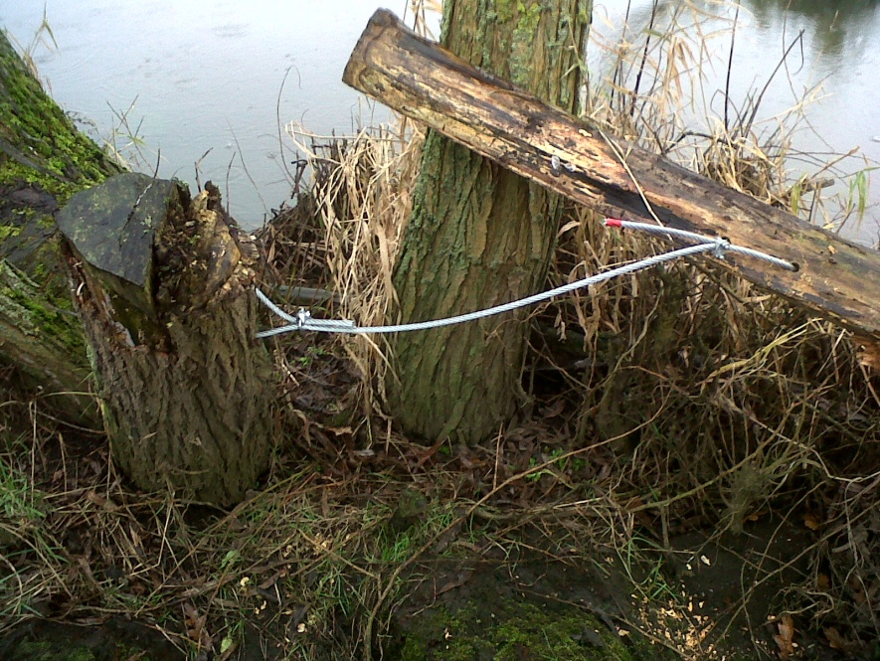
Figure 21: Woody Debris item secured using steel cable and tree stump anchor.

Fish Passage Easement on Gauging Station
Bolting Low Cost baffles onto the downstream face of the crump weir at Gauging Station (B). If possible this work would be carried out in the summer months, when river levels are at their lowest, allowing the weir to dry naturally. Two 6” pumps would be used to start four (or more) 6” pipe siphons from upstream to downstream of weir and would be run continuously to prevent the Long River channel downstream of weir from drying out. If necessary, both 6” pumps would be used in tandem to supplement the 6” siphons. Using an 8t excavator and lifting straps, a number of cubic metre bags of gravel would be placed on the concrete base between wing walls immediately upstream of crump weir to create a coffer dam and dry out the weir face. A 2” pump would be used to manage any leakage through the bags, using the area between bags and top of crump weir as a sump. All water to be pumped downstream of weir. The weir face would be cleaned using a jet wash and wire brushes to allow secure fitment of the baffles. The pre-assembled baffles would be lowered on the weir using the excavator and lifting straps, to use as a template to mark the weir face for drilling. M16 holes would be drilled 100mm into the weir face using a 110v rotary/hammer drill powered by a 110v generator. Chemical resin and M16 x 150mm studs would be fitted into holes using wooden drift and hammer, angle iron and baffle structure fitted, and secured with M16 penny washers and M16 nyloc nuts. Once resin has cured and all baffle structures have been fitted, the bags forming the coffer dam would be removed using the excavator and lifting straps, and the 6” siphons removed from the watercourse.
The works should take approximately two days to complete and would be best carried out when water levels are at their lowest.
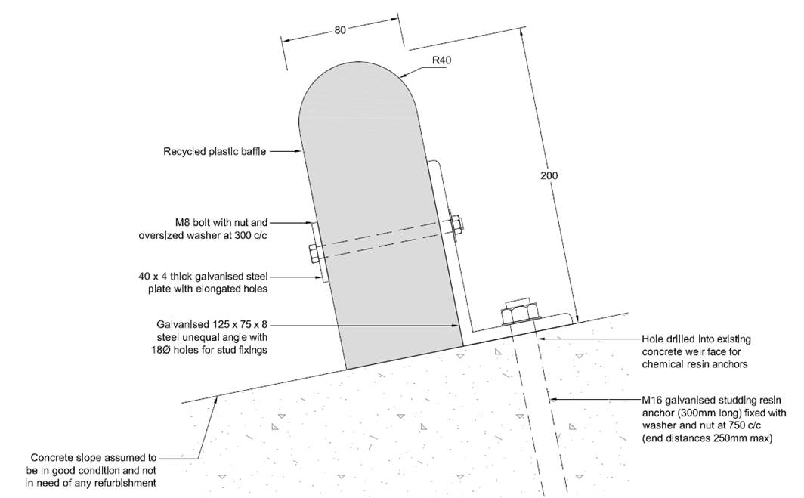
Figure 22: Method of assembling baffle structures and fitment to weir face.

Cleaning and Installing Gravel Spawning Habitat
Gravel can be delivered to site in various quantities and sizes and by various vehicles (either HGV with a Hi-Ab or Land Rover / Tractor and trailer for smaller quantities). It can be introduced to the river channel by hand with manual or motorised wheel barrows, or by means of plant such as tractor with a front loader or an excavator. Gravel can then be spread around the channel by an excavator or manually using hand tools to create natural features (such as pool and riffle sequences) and spawning habitat. Gravel commonly referred to as ‘reject stone’ in the 40mm² to 60mm² size range is ideal for introducing spawning substrate for use by salmonid and cyprinid fish species.
Suitable sites of spawning potential can be identified and improved by manual gravel cleaning using hand tools such as rakes. Venturi style gravel cleaners and petrol-powered 2” water pumps can be used to clean larger areas. This is ideally undertaken outside of spawning season and in water of less than 80cm depth, as the bed level may be dropped by the cleaning. Cleaning is best limited to small areas within the channel, especially with areas of gravel with a high silt volume, as it is possible to drop the bed level considerably by removing the finer material. (See Figure Twenty Two).
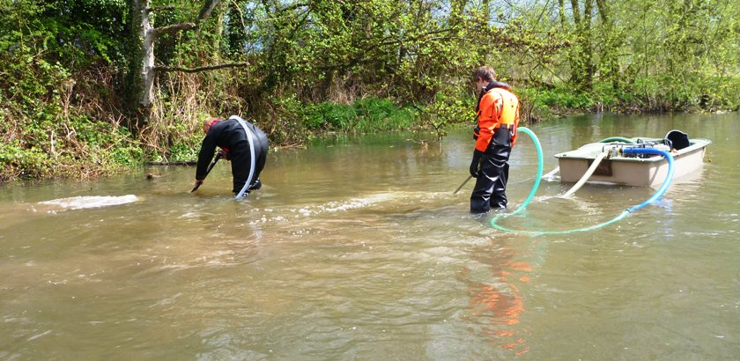
Figure 23: Gravel cleaning using 2" pumps and venturi cleaners.

Appendix A – Supporting Diagrams, Notes and Glossary
- All references to channels, river banks and sides are made looking downstream (river left bank / river right bank).
- A reference to a ‘perched channel’ indicates a channel which is likely to be artificially made, and causes the river to flow through ground on a higher level than it would naturally. This can be caused by an impoundment.
- A reference to an ‘impoundment’ indicates a structure which impounds (backs up or raises) the water levels on river upstream of that structure for whatever reason or by whatever method.
- Head water level refers to the height/depth of water upstream of an impoundment.
- Tail water level refers to the height/depth of water downstream of an impoundment.
- Head difference (or head measurement) is the measurement between the head water levels and the tail water levels on an impoundment, or the measurement between the channel base upstream of an impoundment and downstream of the impoundment.
- It is predominantly the right hand bank of the Long River channel and left hand bank of the Blackwater River channel on which this report concentrates, as these are the banks belonging to the grounds of Wolsey Cottage.
- Flood Defence Consent as required by the Land Drainage Act (1991) should be applied for and received from the Environment Agency prior to any work in or around the river taking place.
- Any work carried out should be timed to minimise any potential or foreseeable impact on the environment, property owner and surrounding land.
- It is strongly encouraged that best working practice around submerged and underground utilities is followed to prevent any utility strike and potential injury occurring during the proposed works.
- This document is solely the opinions and suggestions of the author, and should not be taken as a scientific flood model or legally binding.
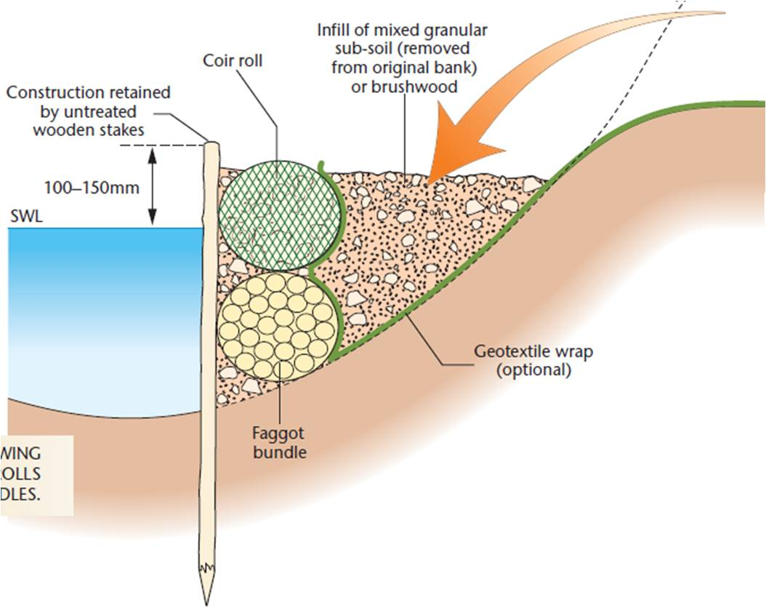
Figure 24: Schematic diagram of proposed Geotextile and faggot bank repair method.

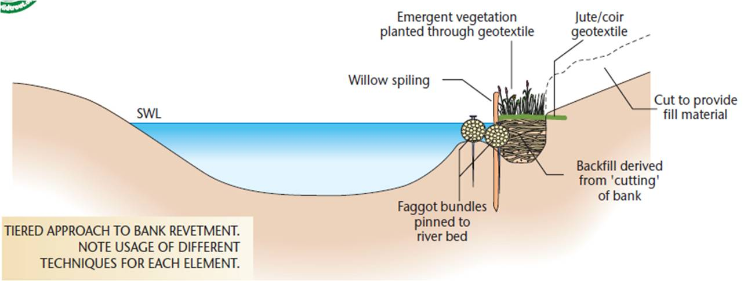
Figure 25: Schematic diagram of proposed cut and fill bank repair method.

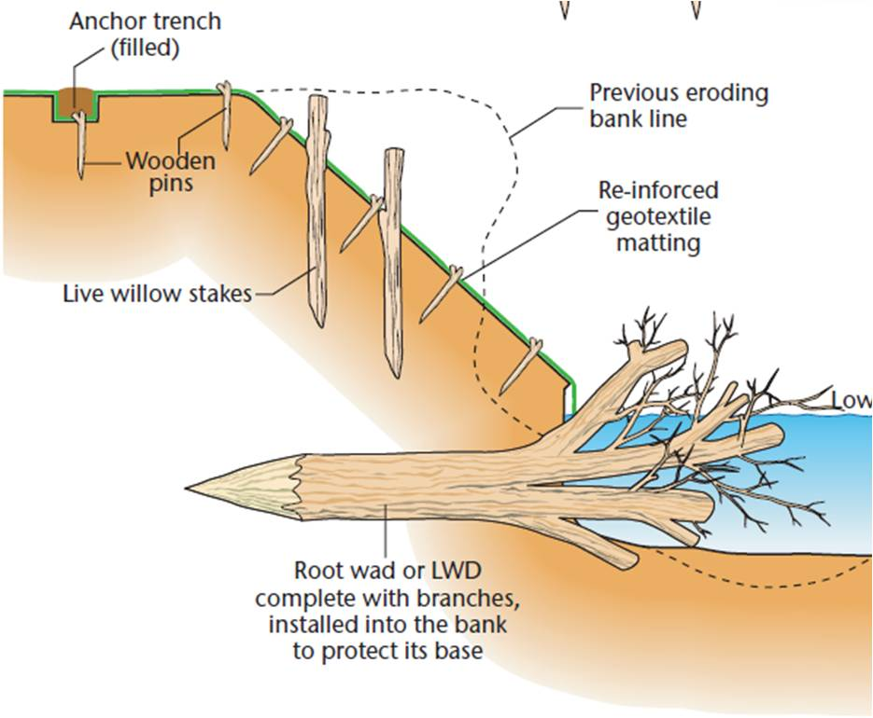
Figure 26: Schematic diagram of proposed Large Woody Debris installation and bank repair method.
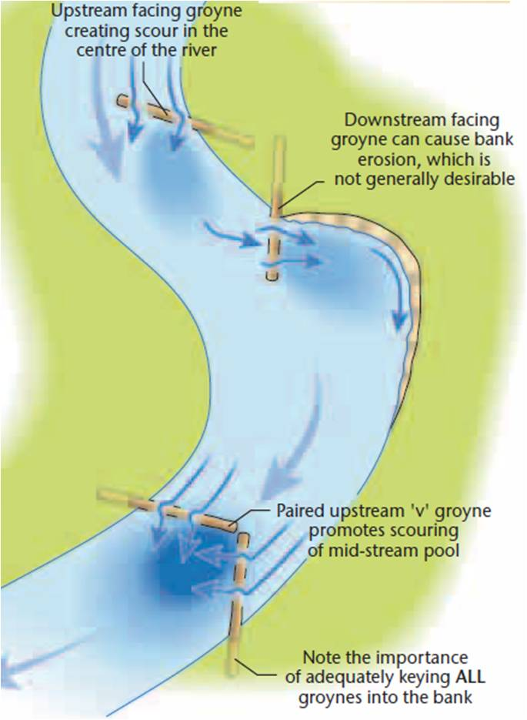
Figure 27: Effects of Large Woody Debris Angles on flow and banks.

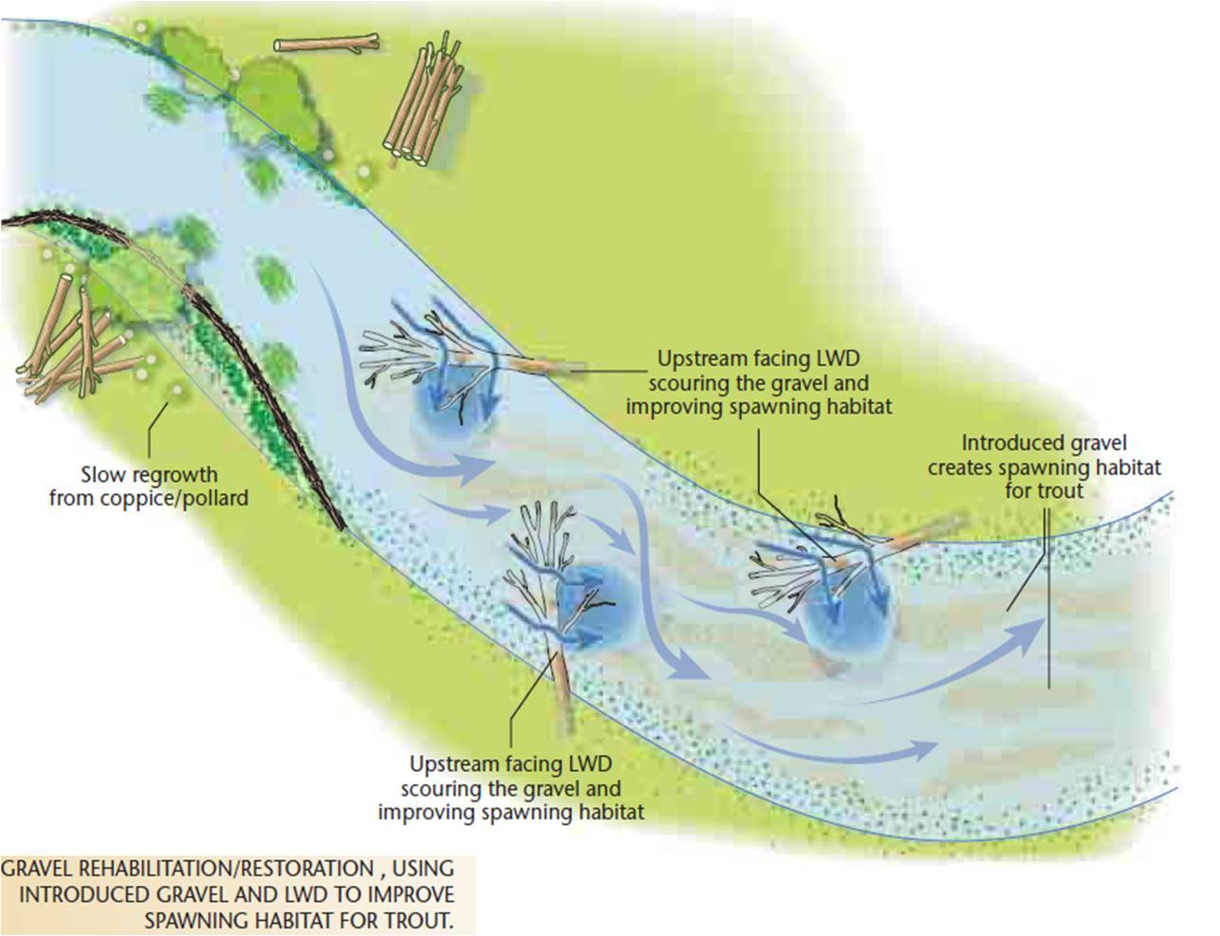
Figure 28: Schematic diagram of impression of finished channel with effects of installed enhancements.

Appendix B – Sources and Recommended Reading
The Wild Trout Survival Guide Third Edition (Wild Trout Trust) 2012
Access for All Design Guide (Environment Agency) 2012
Freshwater Fisheries & Wildlife Conservation (Environment Agency) 2000
River Restoration Centre Manual of Guidance (River Restoration Centre) 2014

Appendix C –Materials, Equipment, Suppliers and Costs

Materials
15 Cubic metre bags of 40mm² gravel rejects
150 1.8m x 50mm untreated chestnut stakes
40 1.5m x 16mm Welded Steel Rebar
100 Metre Roll of 200GSM Coir Roll (3m wide)
100 Metre Roll of Terram 1000 Underlay (3m wide)
100 Metre Roll of GeoGrid (3m wide)
200 Wooden Pegs for Geotextile
1 Low Cost Baffle Kit for Gauging Station (B)
40 3.6m x 0.5m bound Hazel / Willow Faggots
500 2m x 100mm round wooden fence posts
600 3.6m x 100mm half round wooden fence rails

Equipment
1 13t tracked excavator (approx) with grading / digging buckets
1 10t dumper (approx) or tractor and tipping trailer
1 Excavator / tractor mounted post rammer (if undertaking large scale fencing)
1 Towable roller grader (approx 12ft rolling width)
2 6” diameter variable throttle, diesel powered, towable water pump
60 Metres of 6” pipework for the 6” water pumps
1 SDS 110v Heavy Duty Rotary Drill
1 110v Petrol Generator to power the above

Suppliers
This list is not comprehensive and does not represent the author’s approved contractors or suppliers. The author does not endorse any of the companies listed or criticise those that are not listed. Inclusion in this list does not constitute or imply a recommendation by the author.
Verdant Solutions Ltd - www.verdantsolutions.ltd.uk – Will advise on, supply and deliver coir rolls (pre-planted and unplanted), chestnut stakes, geo-fabrics and other geo-textiles to site.
Rivar Sand and Gravel Ltd - www.rivarsandandgravel.co.uk – Will supply and deliver gravel, sand and reject stone in loose deliveries, cubic metre bags or 20kg bags. Material can also be collected from depots based in Newbury, Tadley and Windlesham.
Chambers Group Ltd - www.chambers-group.co.uk – Will supply and deliver gravel, ballast, sand and reject stone in loose deliveries or cubic metre bags by HGV with Hi-Ab. Material can also be collected from depots based in and around Surrey area.
AVS Fencing Ltd - www.avsfencing.co.uk – Will supply and deliver untreated chestnut palings in bundles, either direct to site using HGV and Hi-Ab. Materials can also be collected from depots in Guildford and Wokingham.
Torry Hill Chestnut Fencing - www.torryhill.co.uk – Will supply and deliver untreated chestnut palings of various sizes in bundles, either direct to site using HGV and Hi-Ab. Materials can also be collected from depots in Kent.
Hy-Ten Ltd - www.hy-ten.co.uk – Will supply and deliver steel reinforcing bar cut to any length and various diameters. For using to pin Large Woody Debris, it is recommended that 15mm - 20mm diameter is used.
Metals 4 U - www.metals4u.co.uk – Will supply and deliver steel reinforcing bar in 3m or 6m lengths and various diameters. For using to pin Large Woody Debris, it is recommended that 15mm - 20mm diameter is used.
A1 Building Ltd - www.a1building.co.uk – Will supply and deliver steel reinforcing bar in various lengths and diameters. For using to pin Large Woody Debris, it is recommended that 15mm - 20mm diameter is used.
Honey Brothers Ltd - www.honeybros.com – Will supply Stihl and Husqvarna Power tools and accessories. Will also supply tree work related equipment such as hand saws, log grabs, ropes, ect on the outskirts of Guildford.
Lister Wilder - www.listerwilder.co.uk – Will supply Stihl and Husqvarna Power tools and accessories. Will also supply agricultural tools such as spades, shovels, rakes, forks, saws, and hardware. Depots near Wallingford, Guildford and Reading.
Toolstation - www.toolstation.co.uk – Will supply hand tools, staples, fencing wire, gloves, ect. Will supply steel braided cable and cable clamps of various sizes for cabling.
Arco - www.arco.co.uk – Will supply hand tools, wheelbarrows, fencing staples, fencing wire, gloves, ect.

Costs
Equipment / Materials | Unit / Days | Cost Per Unit / Day | Total Cost | Delivery | Supplier
14t Tracked 360 Excavator HIRE | 7 | £113.14 | £792.00 | £150.00 | Southern Plant Hire
3t 4WD Dumper HIRE | 7 | £30.86 | £216.00 | £150.00 | Southern Plant Hire
Cubic Metre Bag of 40mm2 Gravel | 15 | £35.00 | £525.00 |  | Willis & Ainsworth
1.8m x 50mm Chestnut Stakes | 150 | £2.54 | £381.00 |  | Torrey Hill Fencing
1.5mm x 16mm Steel Rebar | 50 | £4.50 | £225.00 |  | Hyten Steel
Verdatex NW9 (5.25m x 100m) Roll | 1 | £315.00 | £315.00 | £65.00 | EA (FREE)
Armatex G35 (5.25m x 100m) Roll | 1 | £842.40 | £842.40 | £65.00 | EA (FREE)
Verdamat 900g/m Coir (2m x 25m) Roll | 2 | £144.00 | £288.00 | £65.00 | EA (FREE)
Low Cost Baffle Kit for Gauging Weir | 1 | £0.00 | £0.00 |  | EA (FREE)
SDS Drill Hire for Baffle Installation | 1 | £350.00 | £350.00 |  | Southern Plant Hire
Fuel for Plant and Equipment | 250 | £1.50 | £375.00 |  | N / A
TOTAL |  | £1,838.94 | £4,309.40 | £495.00
TOTAL: £4,808.40

Appendix D – Correspondence

Neighbour’s comments on Spawning Fish – 07 / 01 / 2015
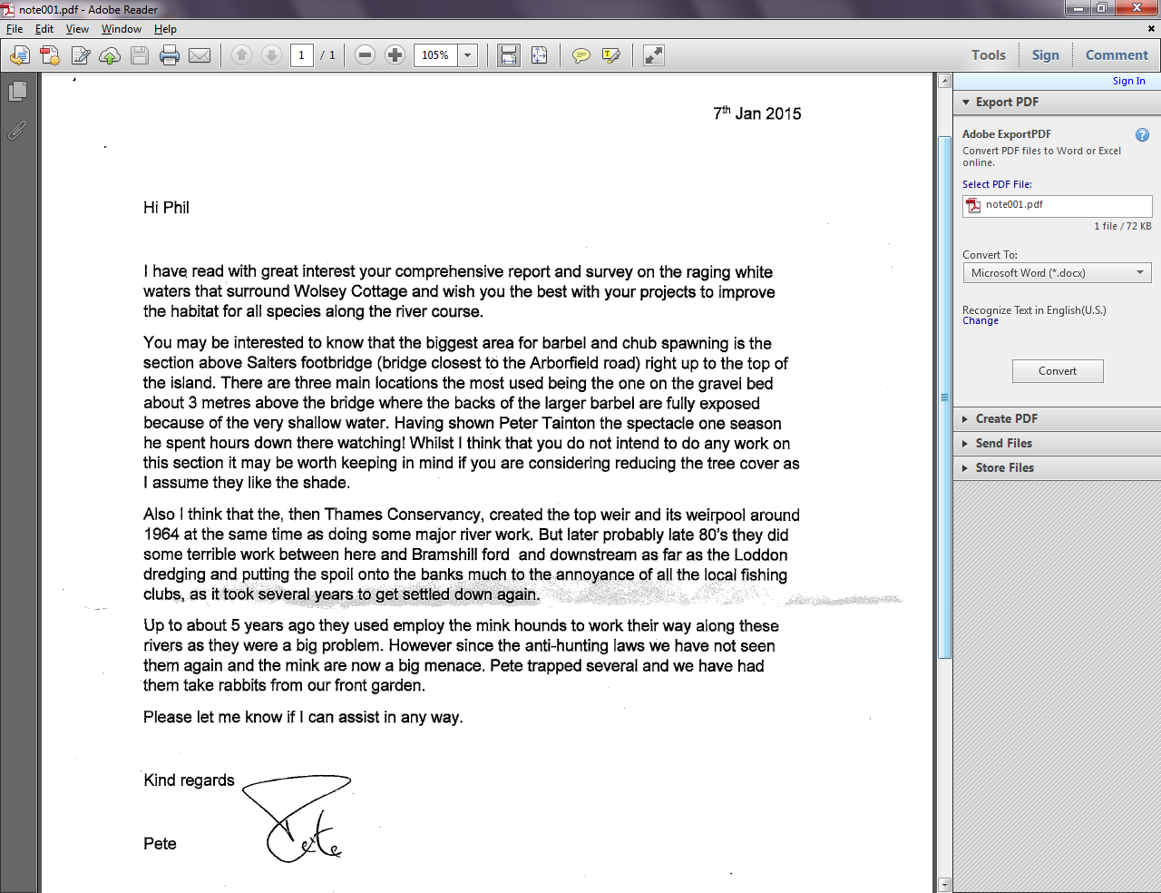

E-Mails from Environment Agency Ref Weir Baffles - 10 / 07 / 2015

From: Drew, Matt
Sent: 09 July 2015 14:46
To: Everitt, Sam
Subject: RE: Low Cost Baffles

Go
for the expanding ones in M16 and those cartridges mate. It only takes one stud out of line and I’m buggered.

M

Thanks and Regards,
Matt Drew
Fisheries Officer
West Thames Area, Environment Agency South East Region

 Follow me on Twitter @MattDrewEA

From: Everitt, Sam
Sent: 09 July 2015 14:44
To: Drew, Matt
Subject: RE: Low Cost Baffles

I’
ve started using resin cartridges instead now.
http://www.screwfix.com/p/no-nonsense-vinylester-resin-fast-curing-380ml/43085

I tend to find, as you mentioned, that the capsules can cause the bolts to shift out of line if not lined up correctly. The free flowing
stuff is much easier to use but the fast setting one goes off really quickly.

I’ve not used them on holes the size you require though so don’t know how suitable it is but would expect it to be fine.

From: Drew, Matt
Sent: 09 July 2015 14:36
To: Everitt, Sam
Subject: RE: Low Cost Baffles

Un
less they do expanding anchors in 16mm – just easier to fit with chemical anchors from experience. Wind it tight and it sits in the
right way till the resin cures

M

Thanks and Regards,
Matt Drew
Fisheries Officer
West Thames Area, Environment Agency South East Region

 Follow me on Twitter @MattDrewEA

From: Everitt, Sam
Sent: 09 July 2015 14:32
To: Drew, Matt
Subject: RE: Low Cost Baffles

Wi
ll do.

From: Drew, Matt
Sent: 09 July 2015 14:31
To: Twine, Karen; Everitt, Sam
Subject: RE: Low Cost Baffles

Sa
m,

I was just going to use the expanding ones for the sole reason that I haven’t got to wait for the resin to cure before I fit the baffles!

I am happy using either – so can we go for the M16 studs?

Cheers

M

Thanks and Regards,
Matt Drew
Fisheries Officer
West Thames Area, Environment Agency South East Region

 Follow me on Twitter @MattDrewEA

From: Twine, Karen
Sent: 08 July 2015 14:39
To: Drew, Matt
Subject: FW: Low Cost Baffles

*U
pdated offer from H&T!*

Dr Karen Twine
Fisheries Technical Officer, Loddon Catchment.

From: Everitt, Sam
Sent: 08 July 2015 14:38
To: Twine, Karen
Subject: FW: Low Cost Baffles

Hi
Karen

I got bored with highlighting. I can supply all of the fixings. I would have supplied the anchor materials
which make up the bulk of the cost anyway.

The anchor bolts listed below aren’t quite correct, the ones below are expanding through bolts, rather
than studs for chemical anchors. I will supply the item below unless he can tell me why not. Matt will
know the difference.
http://www.toolstation.com/shop/Screws+%
26+Fixings/d90/Chemical+Fixings/sd1960/Fischer+RGM+A4+Stainless+Steel+Threaded+Stud/p76697

Just let me know when to place the order.

Sam

From: Drew, Matt
Sent: 09 June 2015 11:15
To: Drew, Matt; Roberts, Andy; Everitt, Sam; Clifton-Dey, Darryl; St Pierre, Paul; Dimmock, Ed; Whalley,
Adam; Weddell, Nick; Twine, Karen
Subject: RE: Low Cost Baffles

All,

Costs just for fittings below – not including angle iron.

http://www.toolstation.com/shop/Screws+%
26+Fixings/d90/Chemical+Fixings/sd1960/Fischer+Eurobond+FEB+RM+Resin+Capsule/p10240 x 15 @
£14.92 each
(Chemical Anchor for concrete)
http://www.screwfix.com/p/fischer-fxa-throughbolts-m16-x-170mm-pack-of-10/49015 x 15 @ £21.49
each
(Anchor bolt for fitting angle iron to concrete)
http://www.screwfix.com/p/bolts-a2-stainless-steel-m8-x-100mm-pack-of-10/31209 x 15 @ £03.87
each
(Bolt for fitting baffles to angle iron)
http://www.screwfix.com/p/hex-nuts-a2-stainless-steel-m8-pack-of-100/12636 x 2 @ £07.57 each
(Nut for fitting baffles to angle iron)
http://www.toolstation.com/shop/Screws+%
26+Fixings/d90/Stainless+Range/sd1030/Stainless+Steel+Penny+Washer/p61907 x 3 @ £05.48 each
(Washer for fitting baffles to angle iron)
http://www.toolstation.com/shop/Screws+%
26+Fixings/d90/Steel+Anchors/sd2040/Stainless+Steel+Setting+Tool/p21750 x 1 @ £2.97 each

The above does not include the galvanised angle iron for fitting. £638.72 is the total for fittings above. I
have estimated 150 fittings across the weir on all baffles (130 means ten fittings per baffle, and there
are 13 baffles – but I’d rather have some spares / too many than too few. The anchors into the
concrete are not stainless steel – in fairness they are never going to be removed if they are secured
with chemical anchors so I don’t see the issue with them.

Thanks

M

Thanks and Regards,
Matt Drew
Fisheries Officer
West Thames Area, Environment Agency South East Region

 Follow me on Twitter @MattDrewEA

From: Drew, Matt
Sent: 09 June 2015 10:10
To: Roberts, Andy; Everitt, Sam; Clifton-Dey, Darryl; St Pierre, Paul; Dimmock, Ed; Whalley, Adam;
Weddell, Nick; Twine, Karen
Subject: RE: Low Cost Baffles

Hi All,

I shall look into the cost of stainless steel – what I will say is that depending on the cost of this, I will
probably be unable to finance it as a private landowner. I am footing the bill in terms of the cost of the
fitting them – my time, hire of plant, et cetera. Gaining fish passage here would be hugely beneficial in
terms of joining three river catchments (Whitewater, Blackwater and Loddon) so it should be a
priority.

I can get most of the fittings from a local supplier and provided I can get Ops to cut the fittings and
baffles to size off site, I can easily fit them – again provided Ops loan me a couple of pumps and bulk
bags of gravel to create a coffer dam. Steve Scott has provisionally said he is happy to loan me two
pumps.

M

Thanks and Regards,
Matt Drew
Fisheries Officer
West Thames Area, Environment Agency South East Region

 Follow me on Twitter @MattDrewEA

From: Roberts, Andy
Sent: 22 May 2015 14:26
To: Everitt, Sam; Clifton-Dey, Darryl; St Pierre, Paul; Dimmock, Ed; Whalley, Adam
Cc: Drew, Matt
Subject: RE: Low Cost Baffles

All

As Sam said we would always look to have stainless fittings in the water. The enables any damaged
parts, or vandalism for that matter, to be pulled out and refitted. Having had to try and undo a load of
galvanised bolts on a weir I cannot recommend trying and then cutting them off and replacing them
too days.

What I would also like to see is that the site is surveyed after the installation to provide an as built
drawing. We could have some tolerance on this, but it will have to be quite tight (+/- 15mm?) to make
sure that things works as per the design.

Cheers

Andy

From: Everitt, Sam
Sent: 22 May 2015 13:24
To: Clifton-Dey, Darryl; St Pierre, Paul; Dimmock, Ed; Roberts, Andy; Whalley, Adam
Cc: Drew, Matt
Subject: RE: Low Cost Baffles

Hi

The designs looks fine in principle, the only change I would suggest is using stainless fixings rather than
galvanised. I have heard from colleagues in the former Midlands region that structural engineers have
said the galvanised steel should be good for 20+ years but in my experience, and Andy can probably
back me up, anything beyond 5 years and you’ll need a grinder to remove it. With stainless fixings
you’ll at least be able to maintain the baffles much more easily if they need replacing.

Rich Holland has consulted customers about this. They should be in touch, I don’t know whether this
will be through THUG or another way but initial feedback to us is positive, we just need to make sure
we have a few things in place before the work goes ahead. Namely downstream level recorders at
Bourne End and Swallowfield, plus some quick analysis of the flow calculation at Swallowfield. This
shouldn’t hold things up.

Cheers, Sam

From: Clifton-Dey, Darryl
Sent: 12 May 2015 06:45
To: St Pierre, Paul; Dimmock, Ed; Roberts, Andy; Everitt, Sam; Whalley, Adam
Cc: Drew, Matt
Subject: RE: Low Cost Baffles

Hi Paul

With these HDPE baffles, they are always fitted with angle steel fitted to the weir crest and the baffle
screwed to the steel. I don’t think that the HDPE is strong enough on its own for direct fitting without
the steel. The South East Rivers Trust do all of the cutting and steel fitting off site, number all of the
pieces, and then just turn up and fit them. This means that they do not have to do so much tricky
cutting when they are on the river bank. They drill extra holes than are necessary in the angle steel,
just in case they hit re-bar. The details of the fixing is in the diagram below.

From a fish passage perspective, the spreadsheet is all that is needed, it sets the length of each baffle,
and the distance from the crest. We don’t need extra drawings, we know what a crump weir looks
like, it is just the consultants making a bit of cash.

Darryl

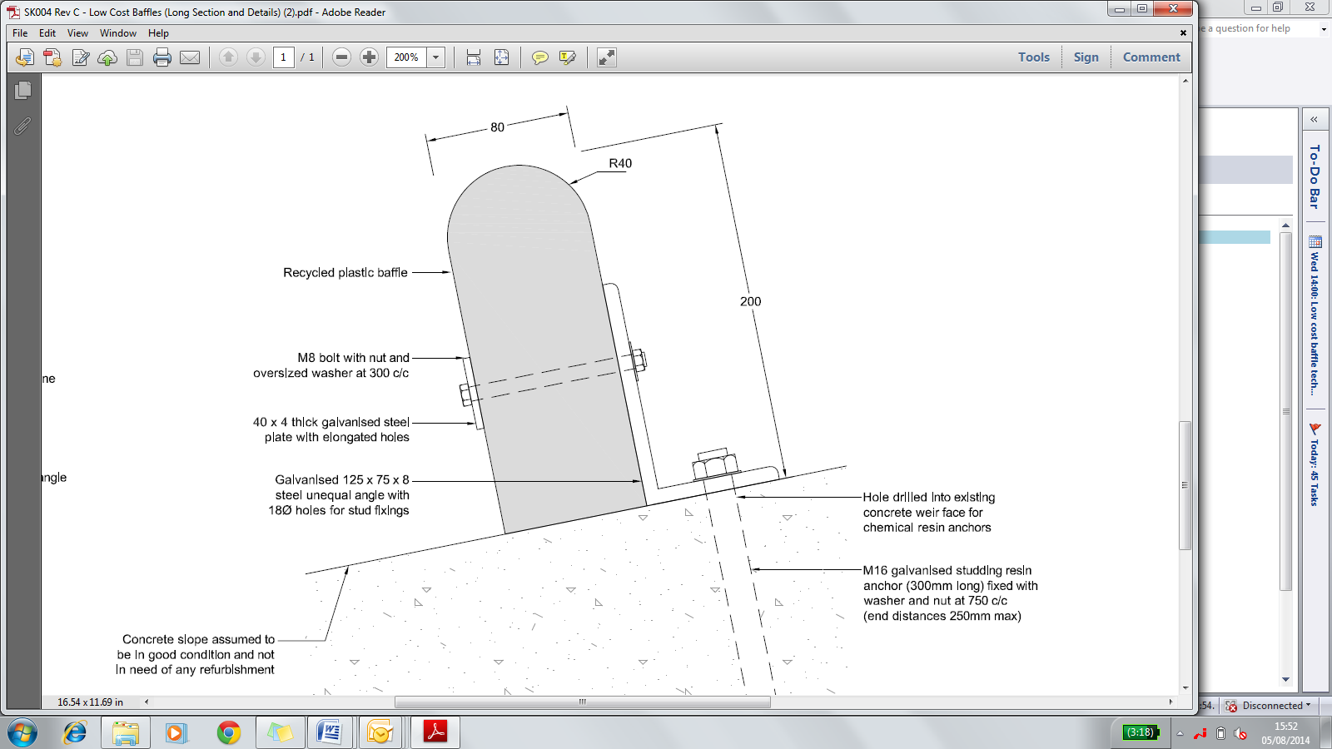

From: St Pierre, Paul
Sent: 11 May 2015 14:48
To: Dimmock, Ed; Roberts, Andy; Everitt, Sam; Whalley, Adam
Cc: Clifton-Dey, Darryl; Drew, Matt
Subject: Low Cost Baffles

Hydrometry bods,

We have sent in designs in for Swallowfield side, Bourne End and Pangbourne recently. Theres
another coming your way shortly for Banbury.

Would it be possible to get confirmation from you that for those that have been reviewed you are
happy for us to move onto construction with.

In terms of approvals from you are you happy with the design spreadsheets alone? The critical
information from your perspective is the height of the baffle and proximity to the cresy – which is all
on the spreadsheet. We would obviously tell you when the work was being carried out and when it
was complete.

Darryl – would you normally expect extra design drawings (as per the Fishtek work at Marlborough) or
are you happy just to go from the spreadsheet. I assume there are multiple ways the baffles can be
fixed – e.g. angle irons or direct fitting with a bolts – or are they only supposed be done with angle
irons?

Paul

E-Mails from Environment Agency Ref Weir Baffles - 02 / 12 / 2014
From: Clifton-Dey, Darryl
Sent: 02 December 2014 21:54
To: St Pierre, Paul; Drew, Matt
Subject: RE: Wolsey Cottage, River Blackwater, Swallowfield
Attachments: Thames GS Priorities.xls

Nice one, Swallowfield is on our list of Gauging Station Priorities too.

According to my records, both of the weirs at Swallowfield are standard Crumps, which makes them perfect for installing the low cost baffles. We would need the H&T team to tell us what the modular head is, we can get the drawings from Survey, and then it takes about 2 minutes to generate a design.

Once we’ve done that one Matt, could you get your family to move next door to the gauging station at Shaw on the Lambourn?

Cheers

Darryl

From: St Pierre, Paul
Sent: 02 December 2014 17:29
To: Drew, Matt
Cc: Clifton-Dey, Darryl
Subject: FW: Wolsey Cottage, River Blackwater, Swallowfield

Matt
Looks like LCB are the only option for now. I’ll put it on the list. We have lots of baffles – if DCD did the design and if you fancied it – we could look for for a way of you doing the construction as a landowner. Basically just drilling and fixing some resin anchors as far as I know. Man of your skills should get it done in a few hours...

P

From: Everitt, Sam
Sent: 02 December 2014 16:26
To: St Pierre, Paul
Cc: Clifton-Dey, Darryl; Whalley, Adam; Holland, Richard; Dimmock, Ed; Twine, Karen
Subject: RE: Wolsey Cottage, River Blackwater, Swallowfield

Hi Paul

I am afraid these weirs are important. We own the weirs, even though the land around them is owned by them.

That being said I’m sure we can come up with a solution and low cost baffles are definitely a sensible option. I did also wonder whether the side channel (the smaller of the two) would lend itself to a Larinier but that is an expensive solution for a weir that already works well, from a Hydrometry point of view.

We can meet up and chat it through. Either on site or at a suitable office.

Cheers, Sam

Sam Everitt | Hydrometry & Telemetry Technical Specialist
Environment Agency | West Thames (South)

Base Office: Goldcrest House, Alice Holt Lodge, Farnham. GU10 4LH.
External Tel: 01252 729581
Internal Tel: 725 4581

From: Dimmock, Ed
Sent: 02 December 2014 16:03
To: Everitt, Sam
Cc: Clifton-Dey, Darryl; Whalley, Adam; St Pierre, Paul; Holland, Richard
Subject: RE: Wolsey Cottage, River Blackwater, Swallowfield

One for the H&T South Team.
Blackwater at Swallowfield GS.

Sam, are you able to respond to Paul please.

Thanks,
Ed

Team Leader, Hydrometry and Telemetry
Environment Agency
Red Kite House, Howbery Park,
Wallingford
OX10 8BD

Internal: 725 8406
External: 01491 828406
Mob: 07836 330925
www.gov.uk/environment-agency
The information provided is based on that currently available to the Environment Agency. The Agency and its officers accept no liability whatsoever for any loss or damage arising from the interpretation or use of the information.
 Consider the environment, do you really need to print this?

From: St Pierre, Paul
Sent: 02 December 2014 15:22
To: Whalley, Adam
Cc: Clifton-Dey, Darryl; Dimmock, Ed
Subject: FW: Wolsey Cottage, River Blackwater, Swallowfield

Adam

See attached from Matt in fisheries team. His family have just bought the land hatched in red nr swallowfield on the River Blackwater. There are crump weirs on both channels. I don’t know how these structures rate in terms of importance but they create a serious blockage to fish movement from the Loddon up into the Blackwater.

Matt is a handy type and is planning on doing work as the land owner to improve the river. If there is any reasonable chance that the weirs are of limited value he can probably do any removal work himself. Similarly he’s/we are quite prepared to install low cost baffles.

I have an action from my team leader to try and move forward with our list of priority structures in terms of fisheries and habitat impacts, so hopefully i’ll soon be able to look at these sort of structures more strategically, but in the meantime any useful comments on the attached issue would be helpful.

Cheers
P

From: Drew, Matt
Sent: 28 November 2014 09:48
To: St Pierre, Paul
Subject: FW: Wolsey Cottage, River Blackwater, Swallowfield

FYI

Thanks and Regards,
Matt Drew
Fisheries Officer - R. Thame, R. Cherwell & R. Wye Catchments (Temporary Cover)
West Thames Area, Environment Agency South East Region

 Follow me on Twitter @MattDrewEA

From: Drew, Matt
Sent: 28 November 2014 09:23
To: Twine, Karen
Cc: Sherwood, Tom; Ramsey, Jonathan R
Subject: Wolsey Cottage, River Blackwater, Swallowfield

Karen et al,

Just so you are aware, we now own part of the R Blackwater up and downstream of the smaller gauging weir on the R Blackwater so will be looking to carry out some river improvements and reduce flooding next year (possibly).

Were there are existing plans on that bit of the river?

M

Thanks and Regards,
Matt Drew

E-Mail from Sam EVERITT, Environment Agency Ref Weir Baffles – 11 / 02 / 2015
From: Everitt, Sam
Sent: 11 February 2015 16:15
To: Twine, Karen; Clifton-Dey, Darryl; Drew, Matt
Subject: Swallowfield Info
Attachments: 109439-12503-C.PDF; 109439-12504-C.PDF

Hi All

Level Duration Info:
Q95 – 0.190 mASD
Q70 – 0.249 mASD
Q50 – 0.301 mASD
Q5 – 0.766 mASD
mASD – metres above station datum (weir crest)

Flow Duration Info:
Q95 – 0.463 m3/s
Q70 – 0.703 m3/s
Q50 – 0.946 m3/s
Q5 – 4.34 m3/s

Q70 can approximately be considered as a ‘normal’ flow. Attached are some plans from an install in Midlands region. The bracket is on the upstream side of the baffle, the theory being to sacrifice the baffle over the weir face. I suggest we use a similar design but using stainless steel for the brackets. We could probably reduce the scale too as the weir in the design is twice the size of ours. This is something to discuss as you get closer to fabrication.

Regards, Sam

Sam Everitt | Hydrometry & Telemetry Technical Specialist
Environment Agency | West Thames (South)

Base Office: Goldcrest House, Alice Holt Lodge, Farnham. GU10 4LH.
External Tel: 01252 729581
Internal Tel: 725 4581

Environment Agency Flood Defence Consent Application – 02 / 07 / 2014

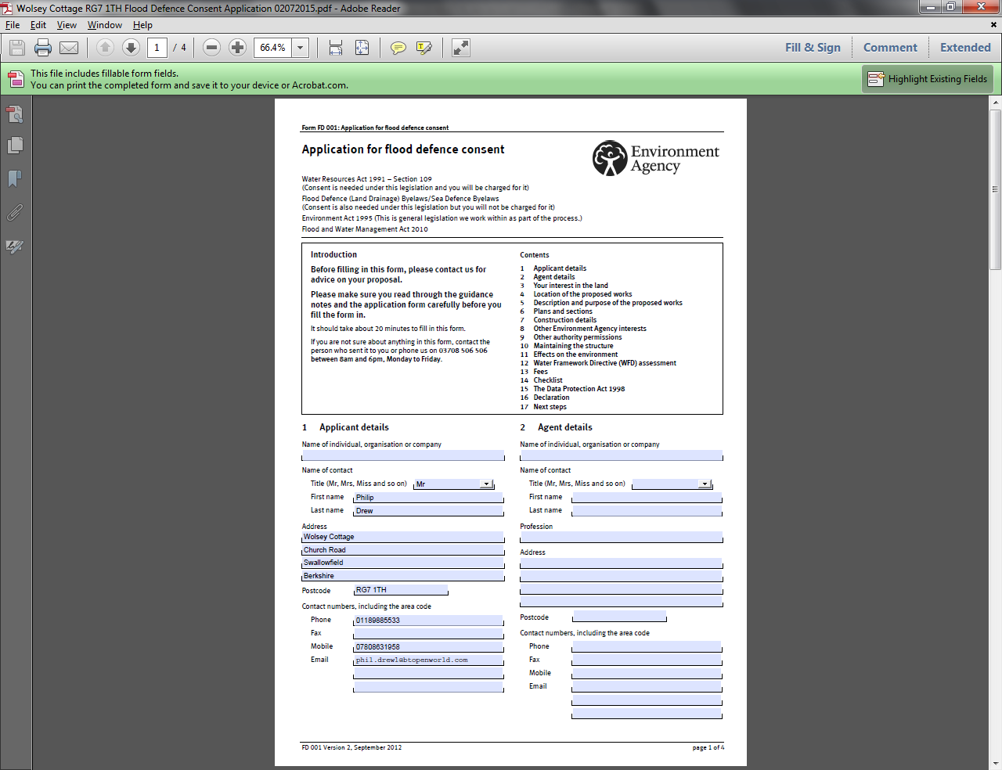
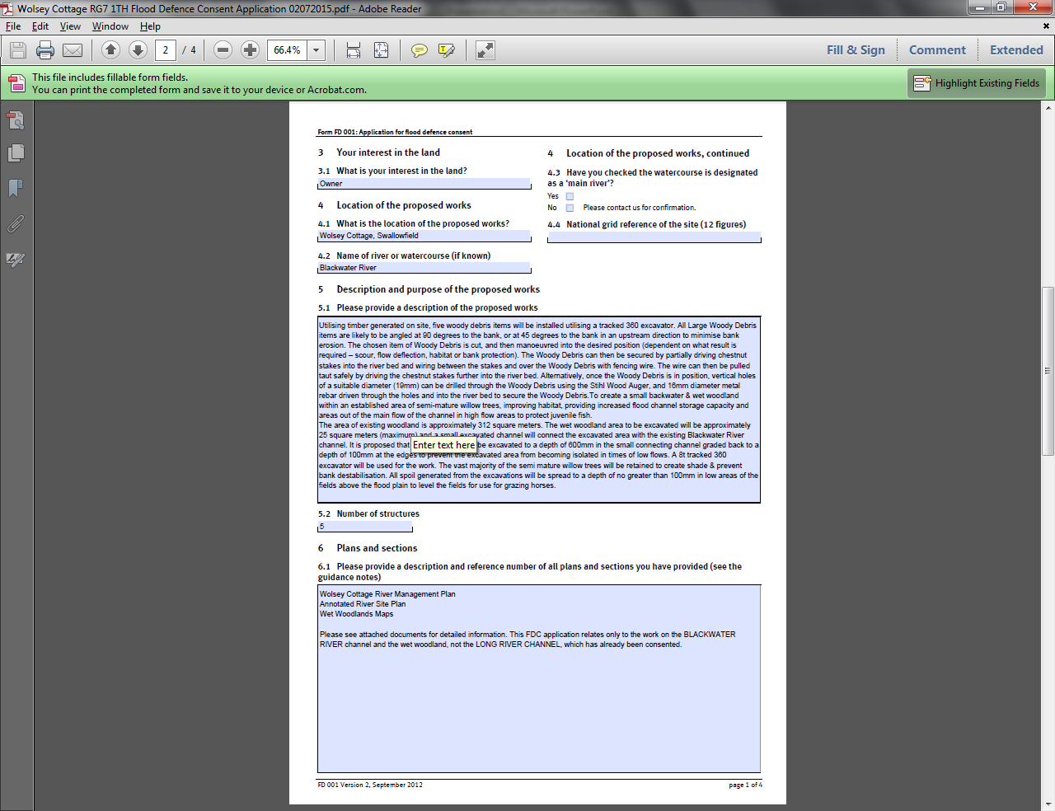

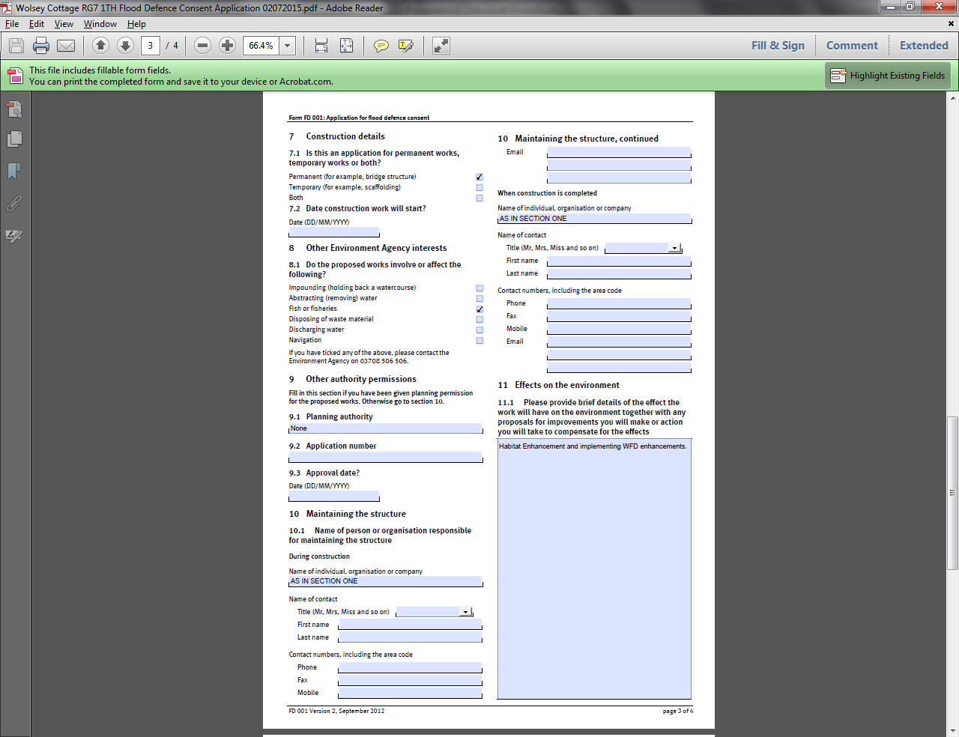

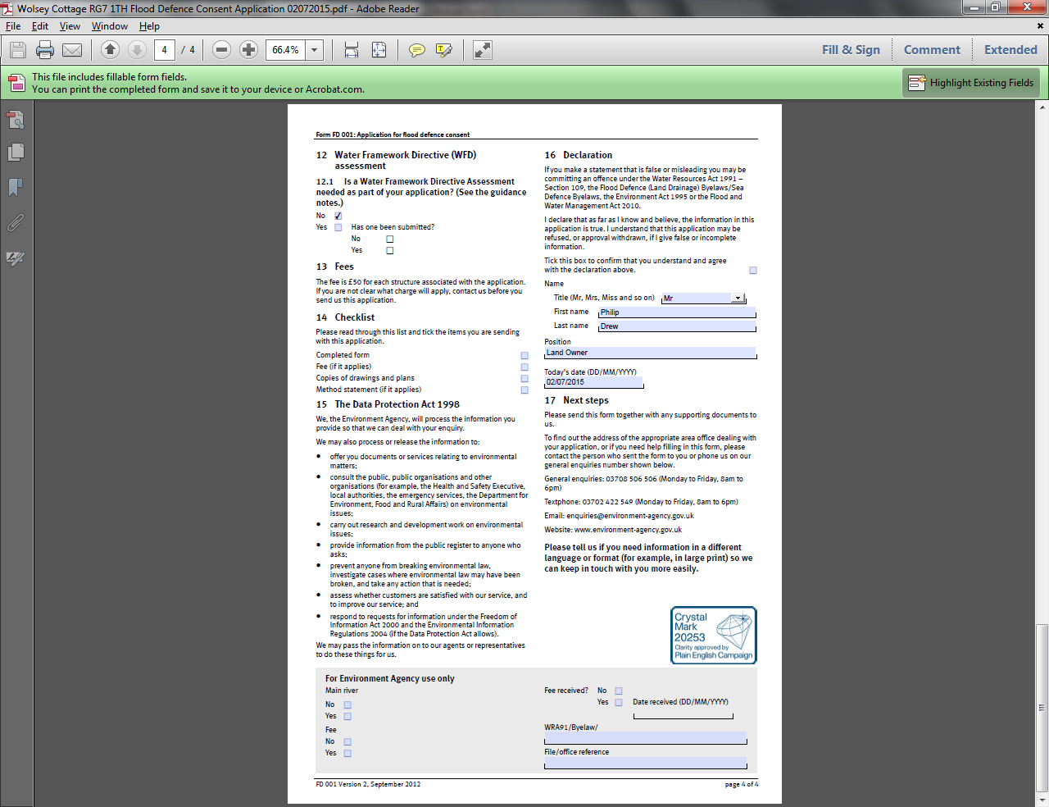

Environment Agency Flood Defence Consent Application – 12 / 12 / 2014

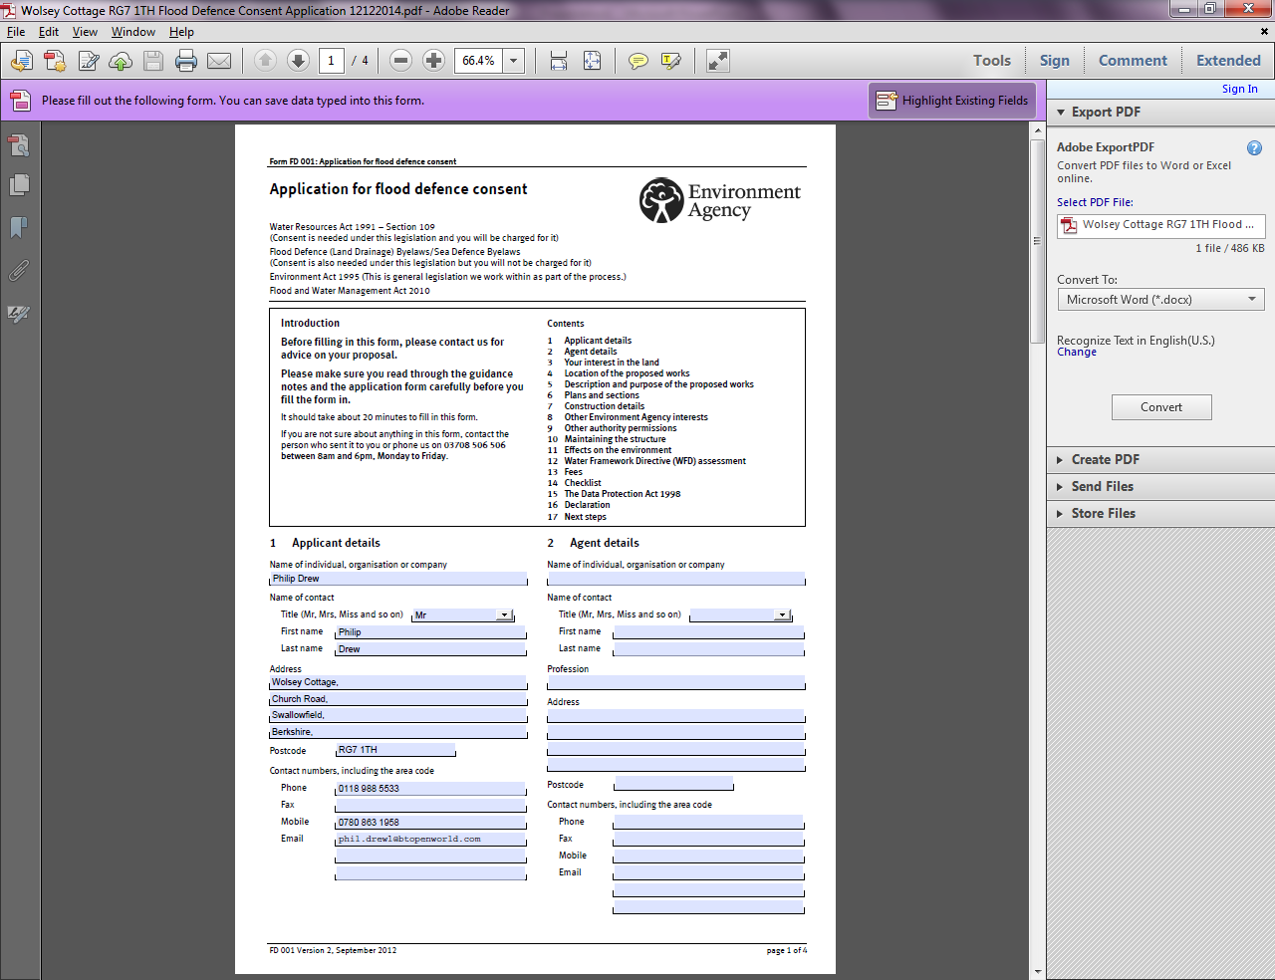

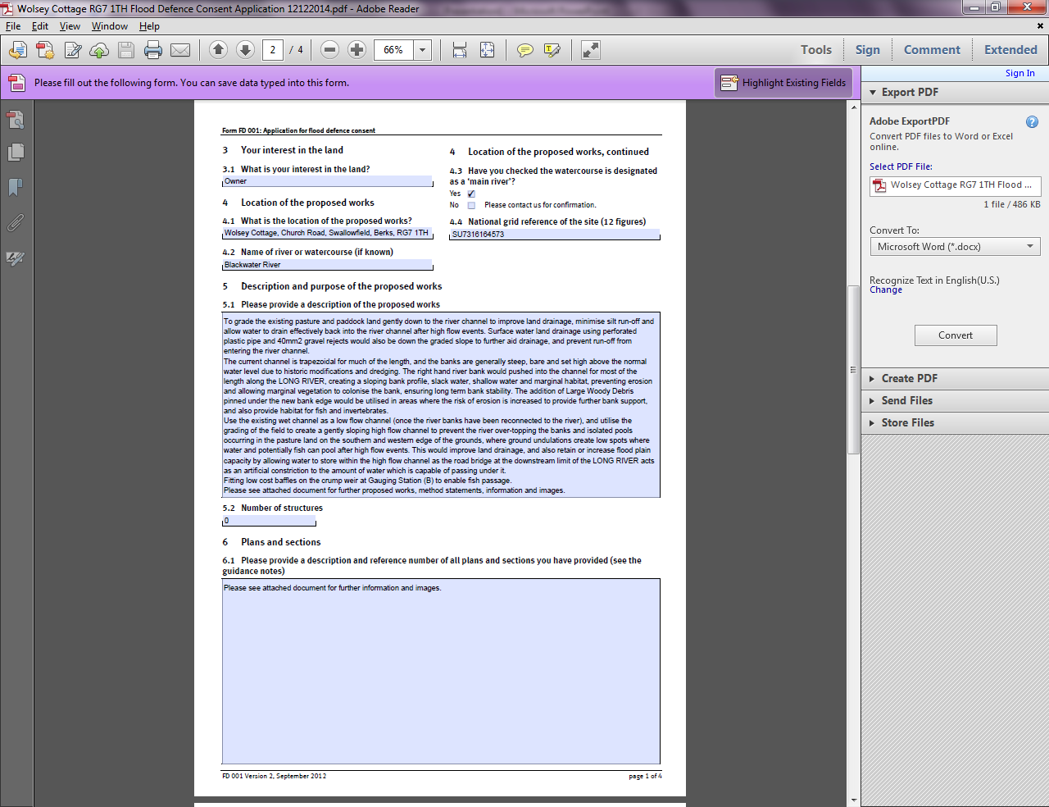

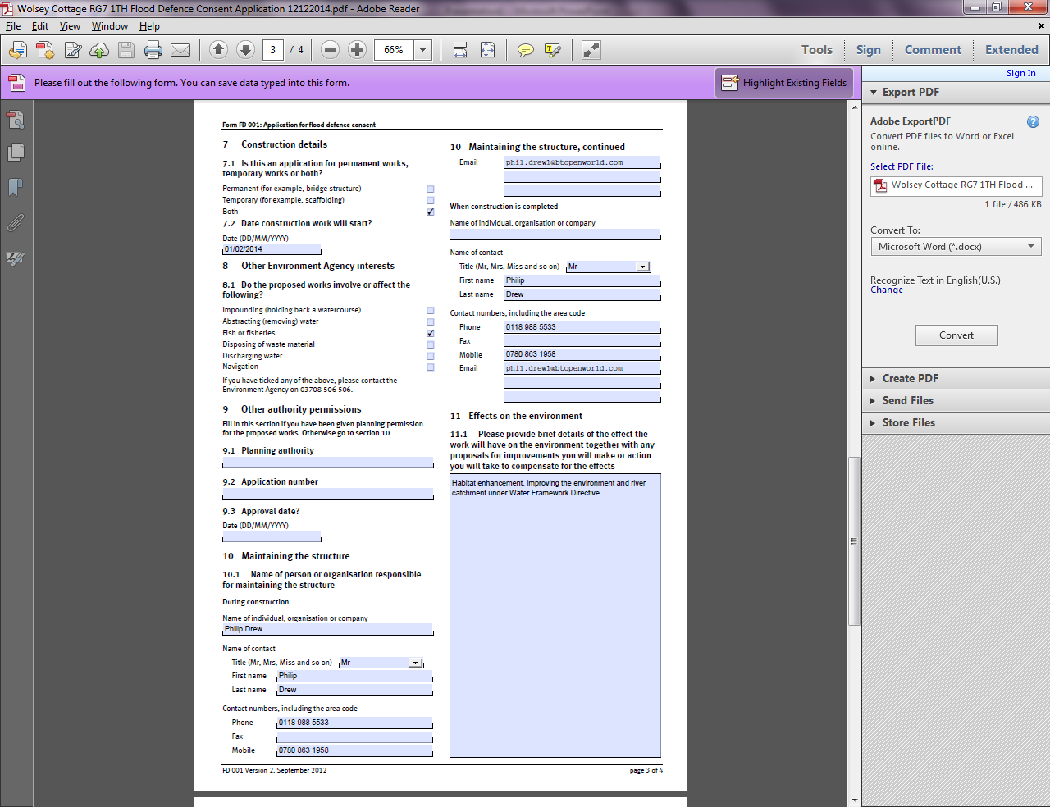

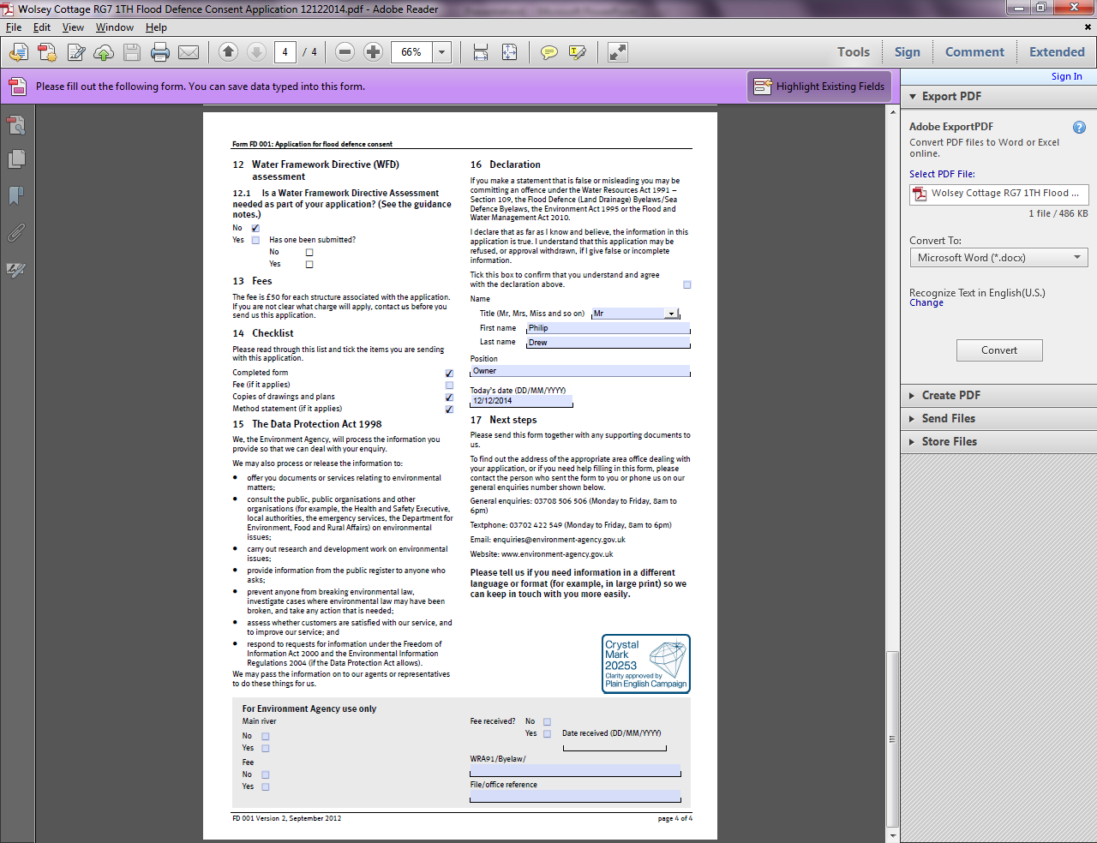

Environment Agency Flood Defence Consent – 20 / 02 / 2015
