
WLMPs Technical Note

Action C.1 Woodsford Channel – Achievements / Outputs

Technical Note: Features and habitats created during 2009

Background
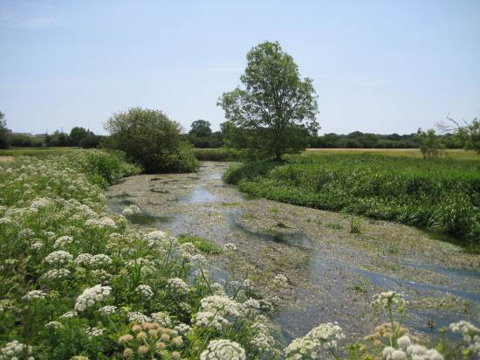
The aim of the project was to enhance a historically dredged reach of the River Frome downstream of Dorchester. Through historical dredging the river had become over deep, wide with little profile diversity. The dredgings (sands and gravels) were often piled on the banks - creating a contained channel and limiting the extent of in-channel features such as gravel riffles that normally provides spawning habitat but were low in quality and occurrence. As a result of previous management little or no woody debris was stored in the channel. These damaging features have resulted in the SSSI designated as in ‘unfavourable condition’, with low fish populations and little marginal habitat diversity.

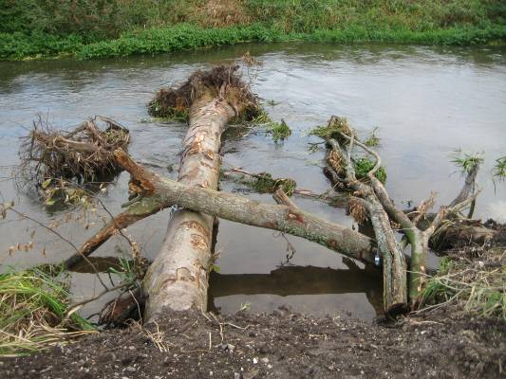
Woody Debris
This feature was missing from the river channel. When present it provides flow diversity and deflection and a range of habitats in and around the structure for the various life stages of several fish species. The trees were all supplied by the Forestry Commission from Puddletown Forest (2 miles away). Totalling 15 trees and 10 additional limbs.

These were installed in the channel as:
4 x individual complete tree deflectors (bank buried)
2 x ‘Tree-Kickers’ (tree attached) deflectors
5 x Log Jams - at least 3 large logs each
2 x still attached limbs of riparian trees.

In channel Features
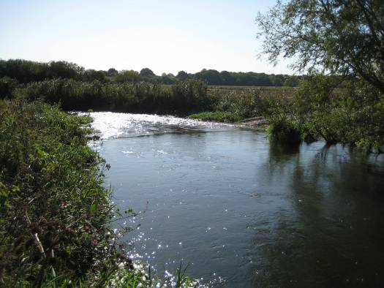
After excavating gravels from the main raised banks 1 riffle was created at the top section. This was approximately 30 metres long and comprised of 350-400 tonnes of gravel.

During the works other gravels were exposed through bank reprofiling works. To make use of this ‘bonus’ gravel 3 additional riffles were created, each about 15-20 metres long. Note that the original reach had just 1 riffle along 2000 metres of river bank.

Channel Reprofiling
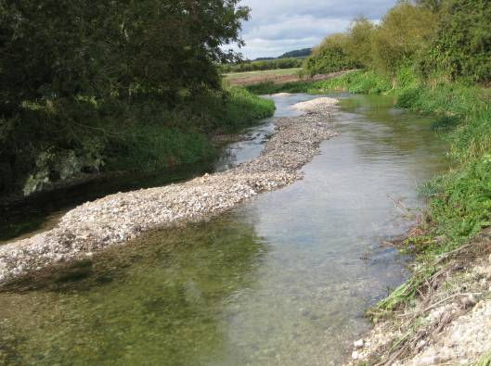
A large proportion of the work involved reprofiling existing material and gravels of the channel. This was to create a more varied cross section profile and hopefully create a greater diversity of habitats. The deeper pools will encourage larger fish.

To achieve this, the existing gravels were moved by machine creating:

- x Large Exposed Gravel berms (more than 75 metres in length)
- x Pools (roughly 2 metres deep and several metres wide)
5 x Gullies (roughly 1 metre deep and totalling 300 metres in length)

Bank Reprofiling
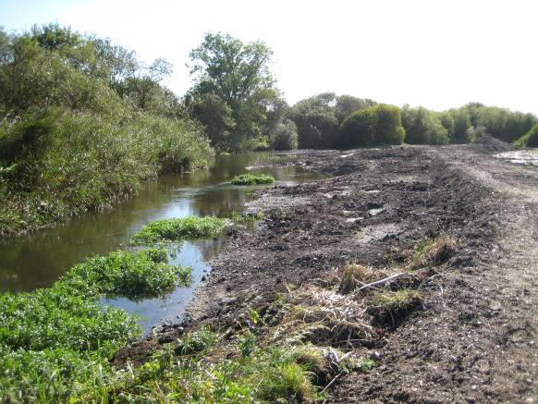
The existing banks at long stretches of the reach were either raised (due to dredgings) or dropped off steeply at rivers edge due to the historic channel works. The aim here was to create a greater marginal habitat zone for aquatic vegetation and animal species. Within this zone exposed mud and gravel berm should be present and the gentle profiles will allow changes in water level to provide a greater range of habitats.

The works created:

- 400 metres of reprofiled bank
- Wider bank having full capacity
- Numerous muddy marginal zones suitable for future colonisation
- 50 metres of back channel (likely to become reedbed in future years)

Additional Outcomes
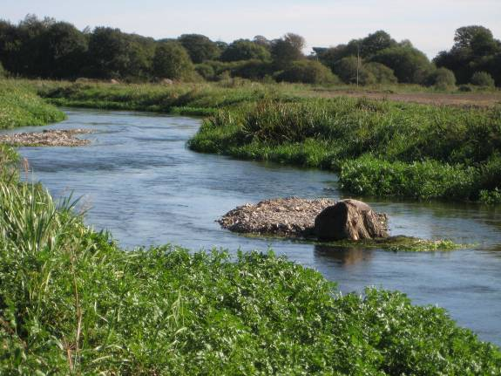
The project also incorporated additional aspects to broaden the habitat gain for the project. These included:
- Planting of 650 native trees (30 centimetre transplants)
- Re-establishing an 80 metre old side channel and creation of an associated island
- Creation of otter holt on the island
- Creation of mid channel island (using an existing tree root ball)

