Ecoremediation system (ERM) for treatment of polluted tributary of Glinščica

Water analyses have shown increased toxicity and pollution loads of the stream Glinščica. The innovative ecoremediation (ERM) system for treatment of the polluted tributary of Glinščica was therefore installed in 2006 and its performance has been monitored since then. The ERM system consists of the sedimentation pond for the deposition of coarse particles and reduction of current flow velocity; the vegetated ditch filled with different mixtures of sand, planted with common reed (Phragmites australis) for the aerobic – anaerobic treatment and meandered, revitalized stream bed of the tributary for the additional treatment. Hydro-morphological, physical and chemical parameters of the polluted tributary were monitored in season 2008/2009 (from April 08 until April 09), in addition to water and sediments' toxicity, reed productivity and ERM system's plant diversity. The results were compared with the results from first (2006/2007) and second (2007/2008) season and the efficiency of pollutants removal in the older ERM system was evaluated with respect to the initial state. The contribution of each part of the system to the efficiency of water cleaning and the contribution of the entire ERM system to the higher area's biodiversity were evaluated. The results showed efficient removal of BOD5 (9%), organic N (24%), ammonia (7%), nitrites (84%), nitrates (68%), total N (40%) and total P (3%) in the entire ERM system in the third season. Vegetated ditch was efficient in removal of ammonia (38%), nitrites (91%) and nitrates (63%) and meandered stream was efficient in removal of total P (10%). With the exception of suspended and dissolved solids, pollutants concentrations at the end of the ERM system stayed within the permitted levels for outflow. The results showed the entire ERM system to be more efficient in removal of nitrites and ammonia in season 2008/2009 compared to previous year. Removal of sediments from the pond proved to be essential for efficiency of vegetated ditch, since the ditch reached higher efficiency for almost all parameters after maintenance work in the summer 2008. The research showed regularly maintained ERM system efficiently decreased pollutants in the tributary of Glinščica and that combination of vegetated ditch and meandered stream for this purpose is an adequate and promising technology that can be further developed (Blumauer, 2010).

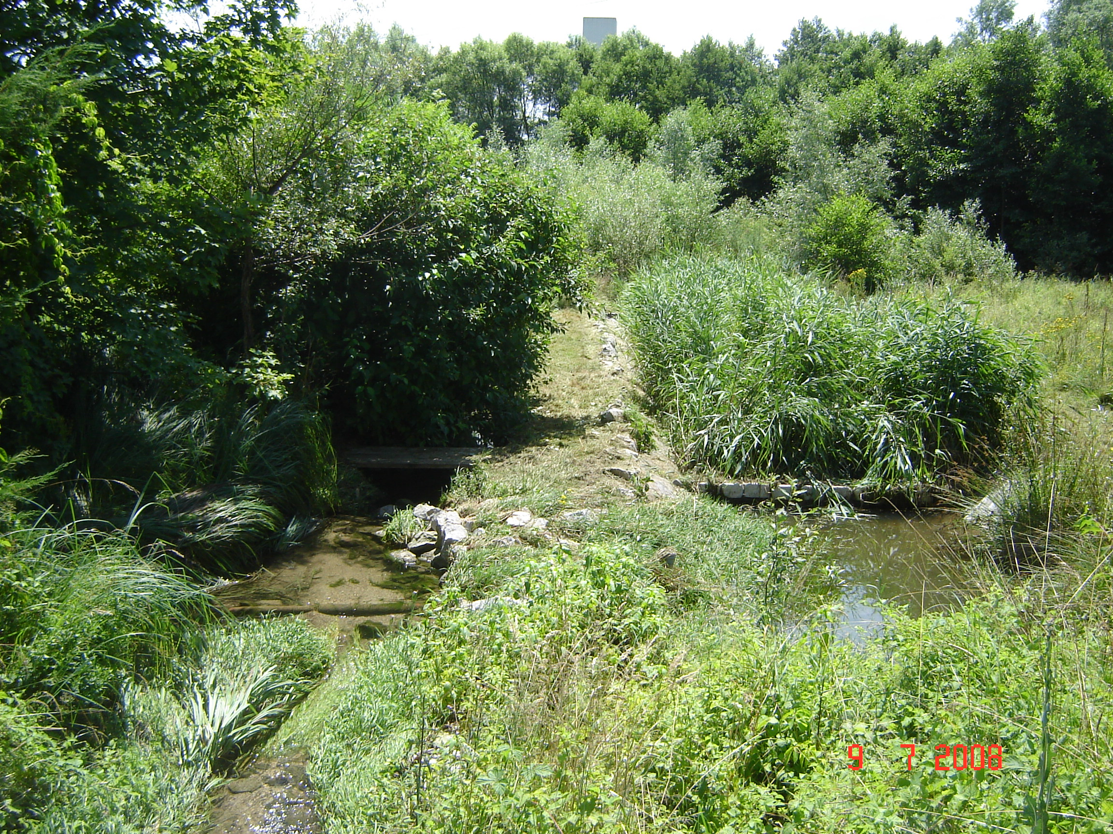
Glinščica tributary (on the left) and treatment ditch (on the right) with a new river bed with meanders (Vzdrževanje …, 2009).
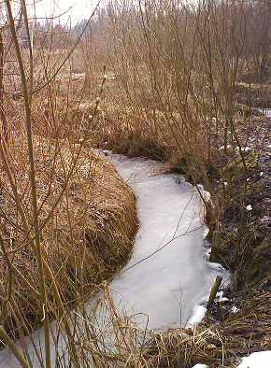
Meandered stream (Photo: S. Blumauer)

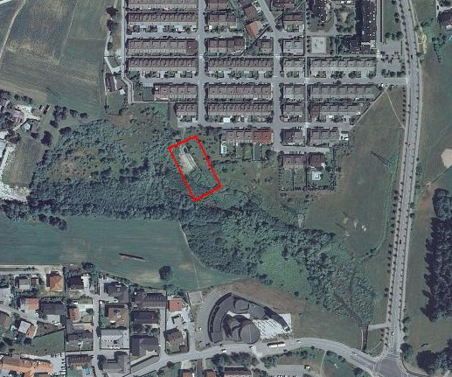
Ortophoto of ecoremediation system location (in red) (Photo: Geopedia).

riverbed
treatment ditch
3
meandered stream
1
2
Glinscica
The vegetated drainage ditches with marked sampling points. 1-inflow, 2-outflow from the treatment ditch, 3-outflow from meandered stream (Griessler Bulc and Šajn Slak, 2007).

- Blumauer S. Primerjava začetnega in večletnega delovanja ekoremediacijskega objekta (ERM) za čiščenje onesnaženega dotoka Glinščice : diplomsko delo : univerzitetni študij = Comparison between the initial and longterm performance of the ecoremediation system (ERM) for treatment of polluted tributary of Glinščica : graduation thesis : university studies. 2010, Ljubljana, 89 p.
- Griessler Bulc T. and Šajn-Slak A. (2007). Agricultural run-off treatment with vegetated drainage ditches. In: Proceedings of the International Conference on Multi Functions of Wetland Systems. Borin M., Bacelle S. (Eds.). Legnaro (Pd), Padova, 86-87.
- Vzdrževanje in spremljanje učinkovitosti ekoremediacijskega objekta na Glinščici. Končno poročilo. 2009. Ljubljana, Limnos d.o.o.: 50 p.

