
Water Level Management Plans Update

Woodsford Channel Summer 2010

River Frome Rehabilitation at Woodsford: One Year On - A Natural Succession

Almost one year since the works began at Woodsford Channel on the River Frome and you can hardly tell a 20T excavator had been used for 6 weeks to reshape this section of the river. The objective of creating a physically diverse channel with back channels, reprofiled banks and a variety of pools and riffles has been achieved.

The subsequent ecological recolonisation of plants and animals anticipated on this SSSI (Site of Scientific Interest) River has now become a reality.
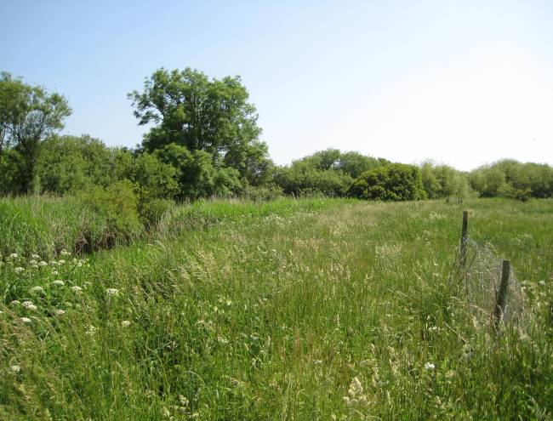
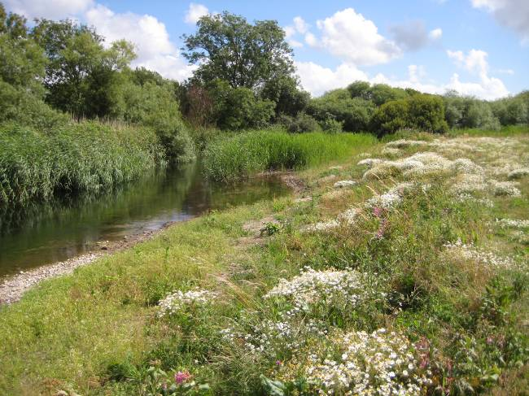
A site visit in July revealed numerous green sandpipers and snipe searching for invertebrates in the muddy backwaters and shallows. A kingfisher was seen fleetingly, disturbed by our approach.
2009

2010

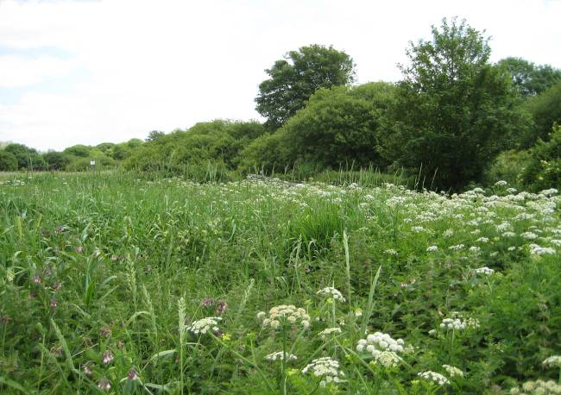
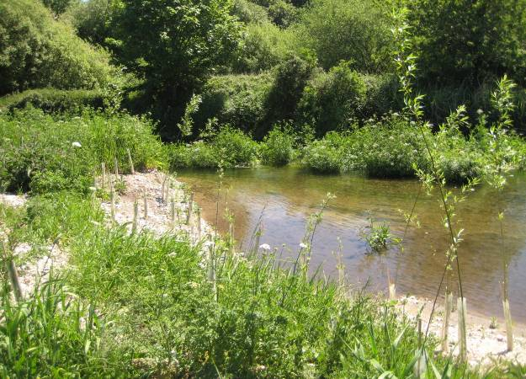
2009

2010

The shallow, muddy, slack back waters of the river also support shoals of fish fry, including salmon, trout, minnows and lamprey, all enjoying the warm slow water and the protection of the marginal vegetation fringes; a habitat that was virtually non existent last year.

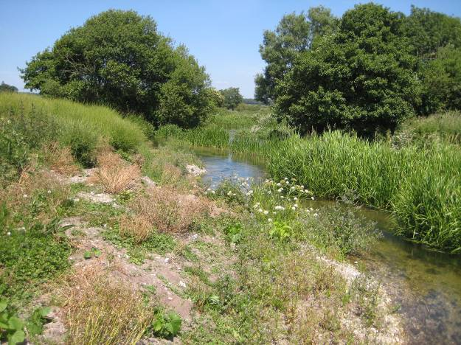
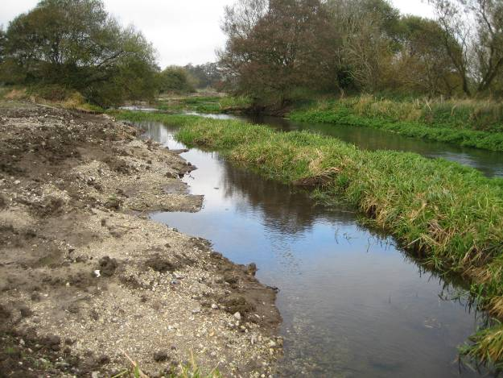

2009

2010

The “large woody debris” installed was a significant and very prominent feature of the project. The debris has remained in place despite high winter flows. Now with water cress and other aquatic plants colonising around these structures they are becoming an increasingly natural part of the river bank, providing the flow diversity and refuge desired. An otter spraint had been observed on one while a frequent kingfisher is using another as a perching point to spot its prey.
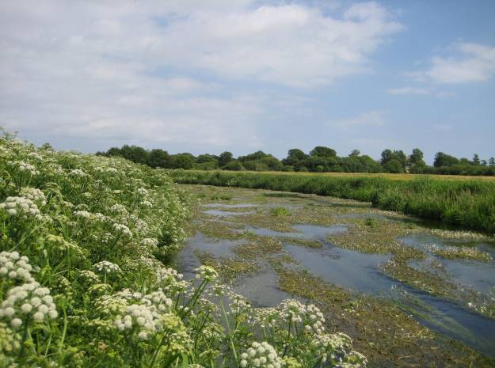
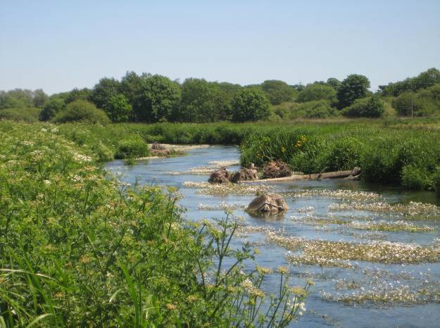

2009

2010

The previous U shaped channel and extensive beds of Ranunculus gave very little diversity in flow and habitats. The mid channel berms and ‘log jam’ deflectors have created a stronger central flow that’s broken up the Ranunculus monoculture.

WLMP ACTIONS – Outcome Focused – Creating a Better Place

All enquiries about the Woodsford project and the River Frome Rehabilitation Plan contact Aly Maxwell on 7 24 3460 or follow the link to the EA’s website for further information

http://www.environment-agency.gov.uk/homeandleisure/wildlife/119502.aspx

